Primer on Key Components of the Reading Reconsidered Curriculum
A guide to support the implementation of the Reading Reconsidered Curriculum Sampler.
This document provides guidance on the following areas:
- Knowledge Organizers
- Retrieval Practice
- Vocabulary
- FASE Reading

Knowledge Organizers & Retrieval Practice

Building background knowledge is one of the keys to accelerating comprehension and understanding of texts. Two key tools for building knowledge and encoding knowledge into long term memory are:
- Knowledge Organizers
- Retrieval Practice

Knowledge Organizers
Knowledge Organizers are one-page documents that organize high-priority knowledge, both for and beyond the unit, that should be encoded in long-term memory through regular Retrieval Practice. The Knowledge Organizer includes elements such as key contextual information, literary terms, timelines of events, important quotations, and relevant historical background.

- Format: They are designed to be quiz-able. The two-column format allows students to cover up one side and quiz themselves on the other. The categories and topics matter— information and the organizing patterns are both useful.
- Content: We’ve included knowledge that is necessary to understanding the book (or unit) and prioritized it by considering what knowledge is important for students to retain “10 years after reading the book.”

Tips for Using Knowledge Organizers:
- Roll it out explicitly at the beginning of the unit to ensure students understand how to use it as a resource. Here’s a sample roll out:

I’m going to share with you a resource called a Knowledge Organizer. It’s just one page, and it includes important knowledge (or information) that will help you better understand our novel and that you’ll be able to apply throughout high school, college, and life. We’ll focus on different portions of the Knowledge Organizer throughout the unit. You’ll often see questions in your lessons that ask you to use information from your Knowledge Organizer. Every other day, I’ll ‘quiz’ you in class during Retrieval Practice, to help you encode this information into your long-term memory, so you won’t forget it. Often, I will ask you to study your Knowledge Organizer for homework, and we’ll talk about ways you might study it on your own, with a family member, or friends.

Since this knowledge is brand new, it’s okay for you to look at your Knowledge Organizer to find specific information. By the end of the unit, you’ll have it completely stored in your long-term memory, so the knowledge is all yours forever.

- Print Knowledge Organizers on paper that will stand out from the rest of their materials (i.e. brightly colored paper and/or cardstock)
- Early in the unit: Allow students to have Knowledge Organizers on their desks during Retrieval Practice and reading
- Teach students how to self-quiz or with a family member/friend at home
- Provide students self-quizzing opportunities:
  - 2-3 minutes before Retrieval Practice (on their own or with a partner)
  - Choose the “Study your Knowledge Organizer” Homework Option
  - As independent review when a student finishes a quiz or Do Now early
- Later in the unit: Ask students to recall information from the Knowledge Organizer without actually letting them look at it.
- It can be easy to lose sight of the Knowledge Organizer, but it’s one of the most important pieces of the curriculum. Strive to provide students opportunities to review it 2-3 times a week. If lesson adaptations cause it to be used less frequently, ensure supplementary opportunities occur, especially during HW or Do Nows.

Retrieval Practice
Retrieval Practice is an academic system in which you ask students questions designed to help encode key knowledge into long-term memory. These questions draw on knowledge from the Knowledge Organizer, the novel itself, or recently read embedded texts. There are Retrieval Practice questions included within particular lessons.

Tips for Planning & Implementation
- Plan your target response for each Retrieval Practice question. You might note these responses in your teacher-created version of the student packet.
- Decide how students will respond to each Retrieval Practice question: Turn and Talk, Cold Call, Raise Hands, Everybody Writes. Students do not need to write the response for every Retrieval Practice question.
- The activity is designed to be fast and energetic with little discussion. The purpose is the retrieval. This helps encode the information in long term memory. A common mistake is to spend time discussing answers to these questions. If students are dying to discuss, it is of course permissible from time to time but doing so is likely to disrupt lesson timings. Occasionally, teachers may choose to engage in brief discussion based on data or to leverage student enthusiasm, but the focus of this section of the lesson should be quick, efficient, and accurate practice.

Vocabulary
The curriculum uses a two-part approach to vocabulary instruction:
- Explicit Vocabulary Instruction: This occurs about 2-3 times per week with words, definitions, and questions that are planned for you.
- Implicit Vocabulary Instruction: This should occur every day during reading. We’ve suggested words to reinforce and provided definitions to support you in the “Words to Watch For” section of the lesson plan.

Explicit Instruction
This is a deep-dive into the meaning and nuances of 1-3 words per day with many opportunities for student practice. The entire explicit vocabulary lesson should take no more than 10 minutes so it’s important to move quickly. There are two components of the explicit vocabulary portion of your lesson:

Roll Out: Introducing the words and definitions. This should take about 2-3 minutes total.

Word and Definition: Read (or have a student read) quickly. No need to discuss.
Related Parts of Speech: Introduce quickly (as needed)

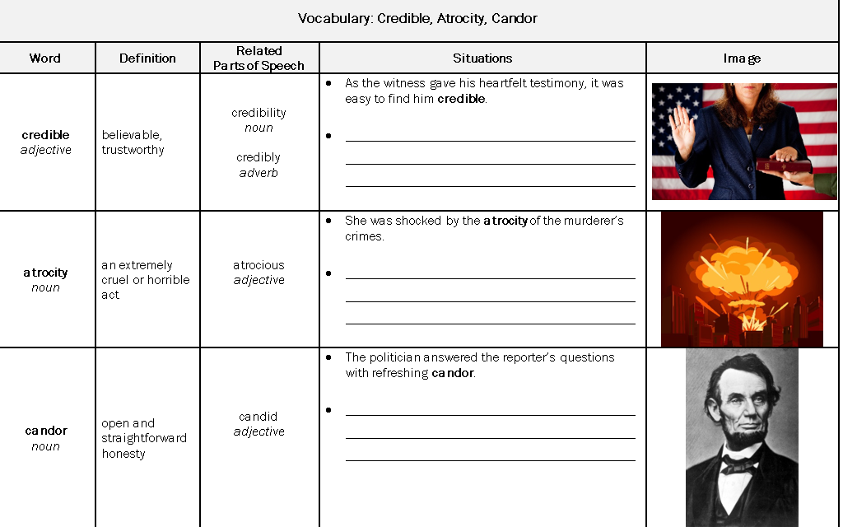

Situations: The blank is for optional use later as practice or self-study. In the roll out just read the example at the top of the box to show how the word is used accurately in context. Then move quickly to the image.
Image: Shift students to focus on how the picture demonstrates the word (while projecting the image). To help students engage with the picture, you might ask a few quick questions like:
- How is she proving her credibility?
- What atrocity has been committed in this image?
- Abe Lincoln was known for his candor. Why is this an important quality for a president?
- Atrocity means a horrible or cruel act. What about this image demonstrates an atrocity?

Active Practice: A series of questions intended to instill and deepen word knowledge; this is where you want to spend the majority of your vocabulary instruction time (7-8 minutes).

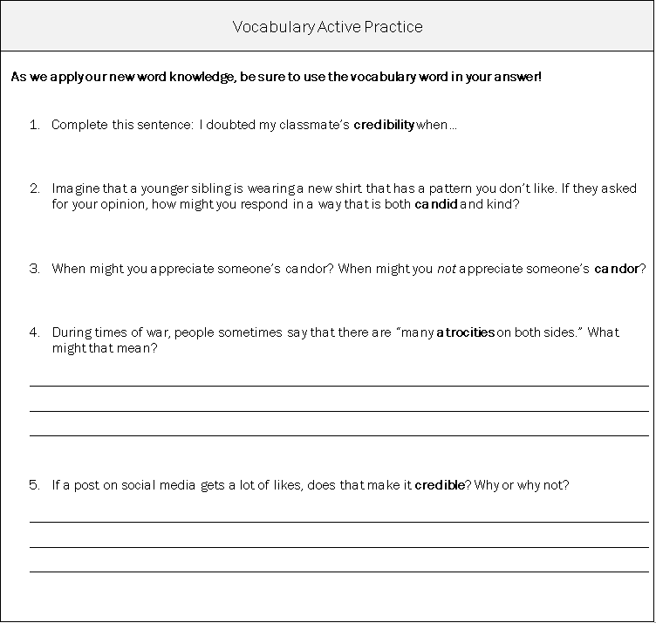

Active Practice Best Practices:
- Be sure that students use the word in their response and use it correctly to illustrate the word’s meaning. You may consider generating some back-pocket phrases to push them to use the word in their response in a way that illustrates they understand its meaning.
  - “Great example. Now, can you use the word ‘linger’ in your response?”
  - “Can you add a detail that shows the meaning of the word? Why did you linger?”
- Invite students to share multiple valid responses but resist the temptation to call on too many students for one word—that can be detrimental to strong pacing.

Tips for Planning:
- Plan your target response for each Active Practice question. You might note these responses in your teacher-created version of the student packet.
- Decide how students will respond to each Active Practice question: Turn and Talk, Cold Call, Raise Hands, Everybody Writes. We suggest that questions followed by a blank space are best answered verbally. Questions with lines below them are generally more challenging, and probably benefit from students writing before sharing aloud if time permits.

FASE Reading (FASE)
A system for shared read aloud between students and teachers, engineered to allow for lots of practice; it builds a culture that celebrates expressive oral reading and the love of the story by and among students. It also ensures that you get a constant flow of data on how well your students are able to make sense of what they read. And it gives you the opportunity to correct and reinforce swiftly in the case of decoding or fluency errors. The name, FASE, is an acronym intended to remind teachers about four things they should try to reinforce when students read aloud.
F is for fluency
A is for accountability
S is for social
E is for expressive
Tips for Planning and Implementation:
- Jot down the names of student readers in the text. Be sure to keep durations unpredictable and relatively short (unless your students are ready to read aloud longer sections). Consider matching sections of text loosely with students’ reading levels (i.e., plan to have a struggling reader read a more accessible section of text).
- Keep the identity of the next reader unpredictable. This prevents students from tuning out while they await their turn.
- Maintain the thread of the narrative by planning how you will quickly and efficiently call on student readers using a minimum of words. (“Thomas pick up.” “Alicia, please.” Or simply say a student’s name.)
- Based on the text, determine when you will read to the class (“Bridging”).
- Determine when/if and how you will Spot Check (use Call and Response for students to fill in key words or phrases when you are reading)
- Reinforce joyful and or expressive reading as much as “Oooh, love the way Daneisha read that!” “Read that line again so we can really hear the possible sarcasm, David”
- Use a placeholder to help students retain their place in the text. This enables a quick and immediate transition back to reading after discussion.

