Note: While all these prompts appear in Lesson 1 of Number the Stars, we would not recommend rolling out all three for the first time in a single lesson. Prioritize which type of prompt you roll out based on students’ previous experience with these prompts and the importance of the prompt to students’ understanding of the objective and Exit Ticket.
Example 1: Art of the Sentence
- In one carefully crafted sentence, explain the setting and mood of this opening.
Teacher | Students
SAY: This question is asking us to include two different ideas in one complete sentence. Before we try to write the sentence, let’s make sure we understand both ideas!  [Turn and Talk] with your neighbor. What is the setting of the opening? What is the mood? Jot a note in the margin. | Turn and Talk:  - mood = joyful, carefree, happy, cheerful  - setting = streets of Copenhagen
[Silent Solo] Now, we need to think about how to combine both ideas into one sentence. On your own, try to write one sentence explaining the setting and mood of the opening pages. | Exemplar: The mood of the opening is joyful as Annemarie and Ellen run through the streets of Copenhagen.
[Show Call]: While observing, look for an example that uses a word like “as” or “while” to express mood and setting at the same time.
Ask: What do you notice about how [Student] combined both ideas? How do we know this isn’t a run on sentence?
Revise: Reread your sentence. Make sure you started with a capital letter and ended with a period. Circle any conjunctions or combining words you used, and put a check mark next to the mood and the setting.  - Add anything that might be missing  - Challenge: Write a new sentence that starts with the conjunction | Challenge Exemplar: As Annemarie and Ellen run through the streets of Copenhagen, the mood is joyful and carefree.
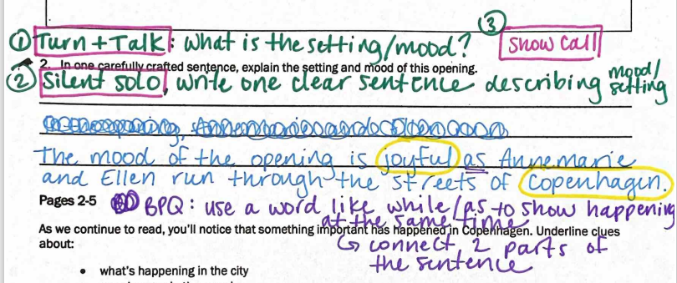
Example 2 – Because, But
- Complete the following sentences:
- Annemarie feels contempt for the soldier because ____________________________________________
- Annemarie feels contempt for the soldier, but ________________________________________________
Teacher | Students
SAY: We’re going to practice with a new type of prompt. This is called developmental writing, and it’s a chance to practice writing strong sentences.  In this type of prompt, we’re given part of a sentence and a conjunction. A conjunction is a word that connects ideas and shows the relationship between them.  Let’s read the first one: Annemarie feels contempt for the soldier because…  The conjunction in this example is because. Circle the word because. The word “because” explains a reason. Why does Annemarie feel contempt for the solider? [Turn and Talk]  (If needed, review definition: contempt means not worthy of respect) | Turn and Talk: Why does Annemarie feel contempt for the soldier?  - He can’t speak Danish  - He has lived in Denmark for three years but hasn’t learned the language
Model: Yes, she feels contempt because the soldier hasn’t learned her language after three years in her country. Now, we can work on completing this sentence to express that idea. Since this is our first time trying this, we’ll write one sentence all together. Please make your paper look like mine. [T write exemplar, S copy]  Make sure you end your sentence with a period. [Cold Call] read us the complete sentence please. | Exemplar: Annemarie feels contempt for the soldier because he can’t speak Danish after living in her country for three years.
SAY: Now, we’ll take a look at the second prompt. What is different in this sentence? [Cold Call] Yes, this one uses the word “but” instead of “because.” The conjunction “but” connects two different or contrasting ideas. So we know Annemarie feels contempt for the solider, but… what does she say or do that contrasts or is different from that idea? [Turn and Talk]  Supporting Questions  - Does Annemarie treat the solider with contempt?  - Does the way she speaks to him match how she feels or is it different?  - What’s different about the way she feels inside and the way she acts outside? | Turn and Talk: What does Annemarie say or do that contrasts with the idea that she feels contempt for the solider?  - speaks politely to him  - treats him with respect  - doesn’t show how she’s feeling  - hides her disrespect
Collectively Worked Example: Let’s try writing this sentence altogether. Make sure your sentence looks like mine. [T writes, S copy]  We already have “Annemarie feels contempt for the soldier, but…” Who are we focusing on here? [Cold Call] Yes, we’re describing Annemarie. I don’t need to use her name again, so I’ll write “she.” But she…what? I need a verb next. [Take Hands] Yes, her action is “speaks.” Who is she speaking to? [Cold Call] Yes, the soldier. We already have those words in the sentence, so we can use the pronoun “he” instead of repeating. Now my sentence says, “Annemarie feels contempt for the soldier, but she speaks to him” Does this sentence fully show the contrast between her feeling and her actions? [Turn and Task] With your partner, finish the sentence. | Exemplar: Annemarie feels contempt for the solider, but she speaks to him politely.

Example 3 – Sentence Expansion
- Expand this kernel sentence with the answers to the following questions:

Annemarie and Ellen walked.

When: ……….………………………………………………………………………………………………………………………………..………….
Where: ……………………………………………………………………………………………………………………………………..…………..…
How: …………………………………………………………………………………………………………………………………………………..……
Why: ……………………………………………………………………………………………………………………………………………………..…
Expanded Sentence: ____________________________________________________________________________________________________________________________________________________________________________________
Teacher | Students
SAY: Let’s practice including several details in one sentence without creating a run-on. We have a kernel sentence here:  Annemarie and Ellen walked.  That doesn’t give us much detail though. First, we’ll brainstorm the answers to each of these questions and jot notes to remember.  - When in the story does this happen? [Take Hands]  - Where do Annemarie and Ellen walk? [Cold Call]  - How are they walking? [Silent Solo, jot a note]  - Why do they walk this way? [Turn and Talk]  Possible Supporting Questions:  - Remember that at first, Annemarie and Ellen were running down the street. When did they start to walk instead? After what event?  - Where are they going?  - When we’re asked how someone does something, we need to give an adverb. Adverbs usually end in -ly and describe how someone does an action (e.g., quickly, happily, excitedly) | When: after being stopped by the solider  Where: home  How: quickly, silently, anxiously  Why: they were frightened/didn’t want to be stopped again
Model: Hmm, if we just write all the details in this order, it won’t make much sense: Annemarie and Ellen walked after being stopped by the soldiers home silently because they were frightened. (non-example)  I want to try to include all these ideas in the clearest, simplest possible way. I’m going to try starting with my When. Let’s write:  After Annemarie and Ellen were stopped by the soldiers…  Now I want to include my kernel sentence: After Annemarie and Ellen are stopped by the soldiers, Annemarie and Ellen walked. I don’t want to be so repetitive, what can I do? [Take Hands] I’ll replace their names with the pronoun “they.  After Annemarie and Ellen were stopped by the soldiers, they walked.  Let’s try to add where and how they walked next. Now my sentence says:  After Annemarie and Ellen were stopped by the soldiers, they walked home silently.  In order to add our why, we need a conjunction. Which conjunction do we use to add a reason or explain why? With your partner, add the conjunction “because” and finish the sentence [Turn and Task] | Exemplar: After Annemarie and Ellen were stopped by the soldiers, they walked home silently because they were frightened.
