Name: __________________________ Date: __________________
Note-Taking Practice
Objective: Practice some techniques for taking effective notes.
Your Turn! We’re going to practice taking notes in an incredibly low-stakes situation using a ‘lecture’ on how to make chocolate chip cookies.
Before we jump in, review your reflections from Lesson G, How to Take Notes During Class. Note two skills you’d like to focus on during this lecture:
- ___________________________________________________________________________________

- ___________________________________________________________________________________
In the spirit of preparing to take good notes, let’s preview what we’re about to watch.
- The talk is titled, “The Science Behind the Perfect Chocolate Chip Cookies – Kitchen Conundrums with Thomas Joseph.”
- The description for the video is, “Soft and chewy, thin and crisp, or cakey? How do you like your chocolate chip cookies? Here’s the answer to creating your perfect chocolate chip cookie.”
- Consider common abbreviations you might want to use to make note taking more efficient! For example, in baking, “cup” is often abbreviated as “c.” For the word “increase,” you might draw an upward arrow or write “inc.”
The best part of watching recorded lectures is that you can play back any part you missed. We’re going to watch this twice so that we can improve upon our notes.
With all of the information above, take a moment to set up your notes on the next page or wherever you would like to take notes.

Apply Your Learning for Note-Taking Practice (Continued)
__________________________________________________________________________________________________________________________________________________________________________________________________________________________________________________________________________________________________________________________________________________________________________________________________________________________________________________________________________________________________________________________________________________________________________________________________________________________________________________________________________________________________________________________________________________________________________________________________________________________________________________________________________________________________________________________________________________________________________________________________________________________________________________________________________________________________________________________________________________________________________________________________________________________________________________________________________________________________________________________________________________________________________________________________________________________________________________________________________________________________________________________________________________________________________________________________________________________________________________________________________________________________________________________________________________________________________________________________________________________________________________________________________________________________________________________________________________________________________________________________________________________________________________________________________________________________________________________________________________________________________________________________________________________________________________________________________________________________________________________________________________________________________________________________________________________________________________________________________________________________________________________________________________________________________________________________________________________________________________________________________________________________________________

Apply Your Learning for Take Note-Taking Practice (Continued)
- Compare to our notes! Now that you’ve taken notes, compare what you have to our initial attempt at notes below. Name at least one thing that is the same between your notes and ours. Identify anything you’d like to borrow from our notes.
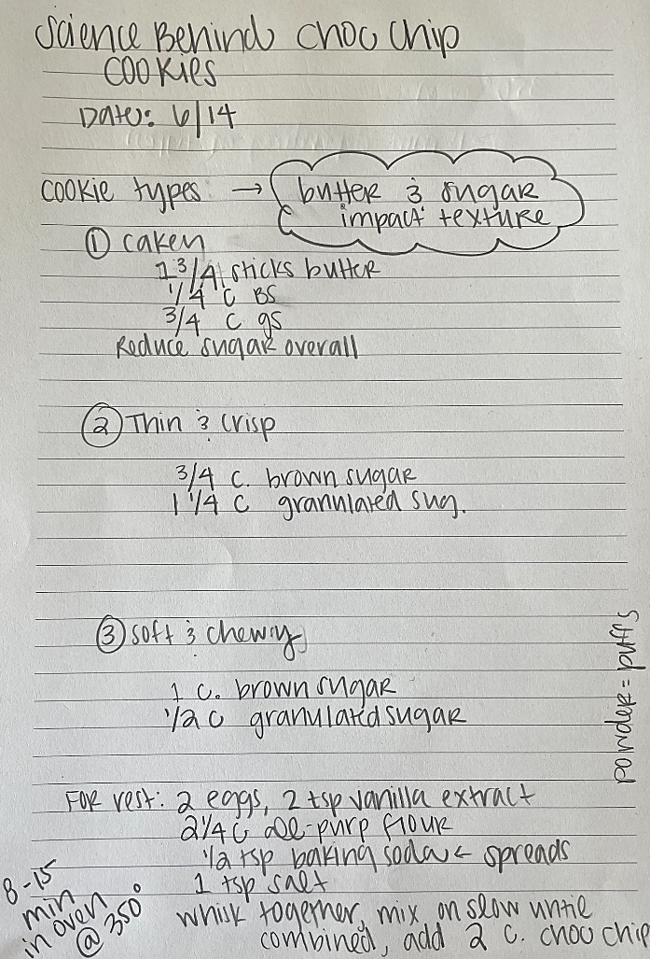
What is the same between our notes and yours?
What would you borrow from our notes/what seems more effective?
Second Watch: Now we’re going to watch the clip again! You have two options for note-taking this time. You can either edit your original notes in a different color (add to them, alter what you have, etc.), OR you may re-write your notes. There is space on the following page to do so if you’d prefer. If you’re re-writing, take a moment to set anything up on the next page that you need.
- Before we jump in, consider: What key ideas did you miss in the first watch? What are you going to pay attention to this time?

Apply Your Learning for Note-Taking Practice (Continued)
____________________________________________________________________________________________________________________________________________________________________________________________________________________________________________________________________________________________________________________________________________________________________________________________________________________________________________________________________________________________________________________________________________________________________________________________________________________________________________________________________________________________________________________________________________________________________________________________________________________________________________________________________________________________________________________________________________________________________________________________________________________________________________________________________________________________________________________________________________________________________________________________________________________________________________________________________________________________________________________________________________________________________________________________________________________________________________________________________________________________________________________________________________________________________________________________________________________________________________________________________________________________________________________________________________________________________________________________________________________________________________________________________________________________________________________________________________________________________________________________________________________________________________________________________________________________________________________________________________________________________________________________________________________________________________________________________________________________________________________________________________________________________________________________________________________________________________________________________________________________________________________________________________________________________________________________________________________________________________________________________________________________________________________________________________________________________________________________________________
Apply Your Learning for Note-Taking Practice (Continued)
- Before you take a look at our notes, compare your edits to your original set. What was helpful about watching the video twice? How did your notes improve?
________________________________________________________________________________________________________________________________________________________________________________________________________________________________________________________________________________________________________________________________________________________________________
- It’s not always possible to listen to lectures twice, like when you’re in a live class. What can you do to fill in the gaps that you missed?

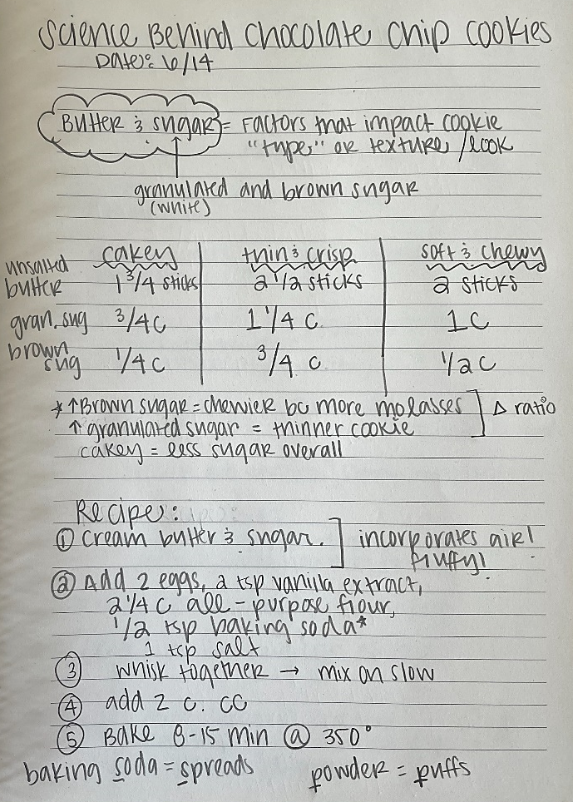
Compare to our notes again! We decided to re-write our notes so we could create a table comparing the butter and sugar amounts in each cookie type.
What is effective about our re-write?
Stamp Your Learning: Note-Taking Practice
- Reflection: Write down 2-3 key ideas you’d like to remember about note-taking for the next time you have an opportunity to use them.

“Kitchen Conundrums with Thomas Joseph,” Everyday Food, August 19, 2014, You Tube video, 4:23, https://www.youtube.com/watch?v=hCzVqaFMlIw&list=PLI9-Km2qj4rR2AIR681eVMDDZJUeGhoBK&index=234.

