Name: __________________________ Date: __________________
Homeroom: _____________________
Paying it Forward
Directions: Read this article and answer the questions that follow.
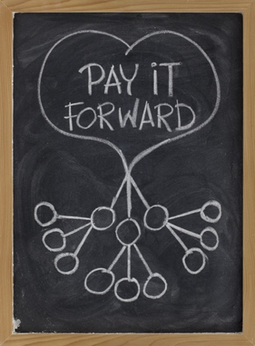
Gratitude isn’t just good for us as individuals. Making a habit of gratitude can also be good for those around us. Like other positive emotions, gratitude can spread to more people than we realize.

According to neuroscientists, one reason why positive emotions like gratitude are “enormously contagious” is because our brains contain special brain cells called “mirror neurons.” As Shawn Achor writes in The Happiness Advantage, these are brain cells that “sense and then mimic the feelings, actions, and physical sensations of another person.” This is why we’re “more likely to laugh while watching a funny movie when we’re in a theater full of laughing people,” or why we’re more likely to smile if we see someone else smiling.

Stop and Jot: Describe the last time you saw something positive happen to a friend or family member. How did you feel? Why?

__________________________________________________________________________________________
__________________________________________________________________________________________
__________________________________________________________________________________________

Emotions like gratitude don’t just create a positive ripple effect on others’ feelings, they can also positively influence the behavior of those around us. For instance, researchers found that when a stranger performed an act of kindness for study participants, they were more likely to “pay it forward” by doing something helpful or kind for someone else. This outcome held true, even when they knew that helping this stranger would personally costly (take at least 30 minutes). In other words, gratitude can inspire us to show more kindness and thoughtfulness towards others. Gratitude becomes the gift that keeps on giving.

Stop and Jot: According to the research, what is one way that positive emotions like gratitude can positively influence the people around us?

__________________________________________________________________________________________
__________________________________________________________________________________________
Reflection Questions for Paying it Forward
Directions: Use what you learned from the article on page 1 answer the following questions.
- Reflect on the last time you saw something good happen to someone you care about. How did it make you feel? Use the research above to explain why. (Use the term “mirror neurons” in your response)
____________________________________________________________________________________________________________________________________________________________________________________________________________________________________________________________________________________________________________________________________________________________
- In your own words, explain why “gratitude often becomes the gift that keeps on giving.”
____________________________________________________________________________________________________________________________________________________________________________________________________________________________________________________________________________________________________________________________________________________________

- Use this table to reflect on how you could show gratitude by doing something nice for someone else.

What’s the last kind or thoughtful thing that someone did for you? | What are TWO kind things you could do for someone else in return? Be specific.

Stamp Your Understanding for Paying it Forward
Directions: Answer the following questions in complete sentences.
- In one carefully crafted sentence, explain how and why showing grattiude can have an impact on the those around us.

________________________________________________________________________________________________________________________________________________________________________
- In your own words, explain the meaning of the expression “pay it forward?” How can you do even more of this in your own life?
________________________________________________________________________________________________________________________________________________________________________________________________________________________________________________________________________________________________________________________________________________

“Gratitude” by Dr. Mary L. Gavin. https://kidshealth.org/en/teens/gratitude.html. Accessed and adapted on 10/14.
mirror neuron: a brain cell that carries messages between the brain and other parts of the body 3 “Pay it forward concept illustrated with white chalk drawing on blackboard” by Mare Kuliasz (Royalty-free stock photo ID: 49081369)
4 The Happiness Advantage: How A Positive Brain Fuels Performance in Work and Life by Shawn Achor

