Name: __________________________ Date: __________________
Homeroom: _____________________
Defining Peer Pressure

Directions: Read the following article and answer the questions that follow.
The Biggest Dose
"Now!" whispered Suki. "Quick, while the clerk's not looking."
Heart pounding, Leah leaned against the store's unattended candy display and slid two candy bars into her purse. Leah looked bored and detached as she followed her friends Suki and Jill out of the store, but inside she felt panicked.
They walked hurriedly to the food court where they ate their candy bars, eyes shifting behind them for a few moments before opening their chocolate.
While sitting at the table in the food court, Jill and Suki were laughing loudly and people began to stare at them in confusion. Leah just sat still, not touching her candy bar.
"I can't believe you made me do that," Leah protested.
"Relax," said Jill. "Everybody does it sometimes--and we didn't make you do it."
She said nothing, but Leah knew she wouldn't have done that on her own. She'd just had a big dose of peer pressure.
Stop and Jot: Jill tells Leah “…and we didn’t make you do it.”. Do you agree or disagree with Jill? Explain your thinking.
________________________________________________________________________________________________________________________________________________________________________________________________________________________________________________________________________________________________________________________________________________________________

Defining Peer Pressure (Continued)
Directions: Review the following definitions and answer the questions that follow.
Influence
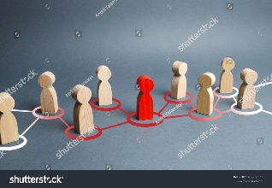 | Influence means causing or persuading something to happen. When it comes to influencing people, each situation is different.  For example, your teachers influence you each day. By teaching you the importance of collegiate skills, teachers are persuading (or influencing) you to believe these skills will guide you through college and beyond!

Peer Pressure
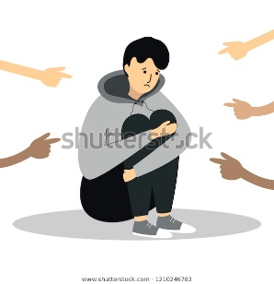 | Peer pressure is when people your age (or close to your age) try to convince you to do something. In some cases, you are told to do something in order to fit in and be accepted by the group.  Peer pressure can be either productive or unproductive:  - An example of productive peer pressure is when your peers convince you to try out for the dance team, even though you’re nervous.  - An example of unproductive peer pressure is when your peers convince you to throw a pencil at another student.  Pressure from others is based on their interests and ideas about ways others should act or attitudes they should show.

Defining Peer Pressure (Continued)
Directions: Review the definitions above and answer the questions below. Be sure to include the bolded word in your response.
Application of Terms
- What is one way someone has influenced you or you have influenced someone else?
__________________________________________________________________________________________________________________________________________________________________________
__________________________________________________________________________________________________________________________________________________________________________

- Describe a time you or someone you know has experienced peer pressure in a productive way.
__________________________________________________________________________________________________________________________________________________________________________
__________________________________________________________________________________________________________________________________________________________________________

- Describe a time you or someone you know has experienced peer pressure in an unproductive way.

__________________________________________________________________________________________________________________________________________________________________________
__________________________________________________________________________________________________________________________________________________________________________

Defining Peer Pressure Reflection Questions
Directions: In your neatest handwriting and in complete sentences, answer the following questions:

- In your own words, define peer pressure. Include at least one way a person may experience peer pressure at school.
____________________________________________________________________________________________________________________________________________________________________________________________________________________________________________________________________________________________________________________________________________________________
- Reread the last paragraph of The Biggest Dose. What does the author mean “She’d just had a big dose of peer pressure?”

____________________________________________________________________________________________________________________________________________________________________________________________________________________________________________________________________________________________________________________________________________________________

- If you were Leah’s friend, how could you help her understand how peer pressure influenced her decision?

____________________________________________________________________________________________________________________________________________________________________________________________________________________________________________________________________________________________________________________________________________________________

Stamp Your Learning for Defining Peer Pressure
Directions: Answer the following questions in complete sentences.
- Review the defintiions for “influence” and “peer pressure”. How are influence and peer pressure related?

____________________________________________________________________________________________________________________________________________________________________________________________________________________________________________________________________________________________________________________________________________________________

- Review the defintiions for “influence” and “peer pressure”. How are influence and peer pressure different? Why is that important?

____________________________________________________________________________________________________________________________________________________________________________________________________________________________________________________________________________________________________________________________________________________________

- How might understanding peer pressure influence your decisions in the future?

____________________________________________________________________________________________________________________________________________________________________________________________________________________________________________________________________________________________________________________________________________________________

Digital Illustration of a chocolate candy bar by Umy Art
KidsHealth: Peer Pressure by D. Lyness, PhD https://kidshealth.org/en/teens/peer-pressure.html?ref=search Accessed and edited on 12/12/19
detached: unemotional
dose: an amount of something that a person experiences
Red human figure…by Andrii Yalanskyi (Royalty-free stock photo ID14277728532)
Fingers pointing…by Alona Savchuk (Royalty-free stock vendor ID 1210246783)
peers: people your age or close to your age

