Name: __________________________ Date: __________________
Homeroom: _____________________
Quotes about Goal Setting

Directions: Review the quotes below. Paraphrase what they mean in your own words and then decide whether you agree with the quote. Explain why or why not.
Quote | Paraphrase the Quote | Do you agree with this quote? Why or why not?
“I’ve missed more than 9,000 shots in my career. I’ve lost almost 300 games. Twenty-six times I’ve been trusted to take the game winning shot and missed. I’ve failed over and over again in my life, and that is why I succeed.”
— Michael Jordan, American professional basketball player
“Some of us have great runways already built for us. If you have one, take off! But if you don’t have one, realize it is your responsibility to grab a shovel and build one for yourself and for those who follow after you.”
— Amelia Earhart, American aviation pioneer and author
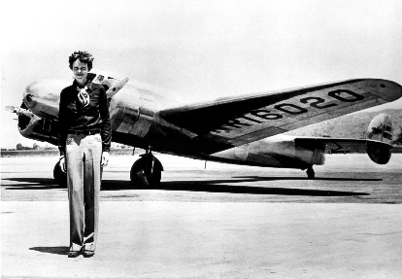
Quotes about Goal Setting (Continued)
Quote | Paraphrase the Quote | Do you agree with this quote? Why or why not?
“As soon as I accomplish one thing, I just set a higher goal. That’s how I’ve gotten to where I am.”
— Beyoncé American singer, songwriter, and actress
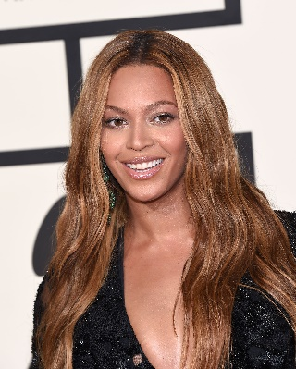
“Effort makes you. You will regret someday if you don’t do your best now. Don’t think it’s too late to keep working on it. It may take time, but there’s nothing that gets worse due to practicing.”
— Jeon Jungkook, South Korean song writer and singer, member of the band BTS

Quotes About Goal Setting (Continued)
Quote | Paraphrase the Quote | Do you agree with this quote? Why or why not?
“Set realistic goals, keep re-evaluating, and be consistent.”
— Venus Williams, American professional tennis player
“I know how it looks. But just start. Nothing is insurmountable.”
— Lin Manuel Miranda, American actor, songwriter, singer, playwright, and director; best known for creating and starring in the Broadway musicals Hamilton and In the Heights
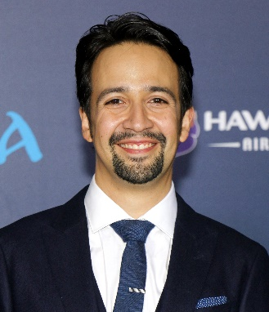

Stamp Your Learning for Quotes About Goal Setting
Directions: Answer the following questions in complete sentences.
- Which quote can you apply starting tomorrow? How would you apply it?

____________________________________________________________________________________________________________________________________________________________________________________________________________________________________________________________________________________________________________________________________________________________
_______________________________________________________________________________________

- Select one quotation from above and rewrite it to align to three out of five of the components of SMART goals (Specific, Measurable, Attainable, Realistic & Relevant, or Time-bound).

____________________________________________________________________________________________________________________________________________________________________________________________________________________________________________________________________________________________________________________________________________________________
_______________________________________________________________________________________

