Name: __________________________ Date: __________________
Managing Social Media – Setting SMART Goals
Objective: Create SMART goals for social media use.
Directions: Answer the questions that follow in complete sentences.
- Juan and Karina are both committed to spending less time on TikTok. They have each created goals for themselves.
Karina: | I am going to limit the number of times I access TikTok every day.
Juan: | On weekdays, I am going to limit my use of TikTok/Instagram to 25 minutes in the morning and 45 minutes after I’ve completed my homework in the evenings. I will use a tracker to keep up with my use for 2 weeks.
After a week, who is probably better able to assess whether they are meeting their goals? Why?
Notes

Managing Social Media – Setting SMART Goals

- When setting goals for yourself, making them SMART (Specific, Measurable, Attainable, Relevant, and Time-bound) can help you make them more manageable and easier to measure.
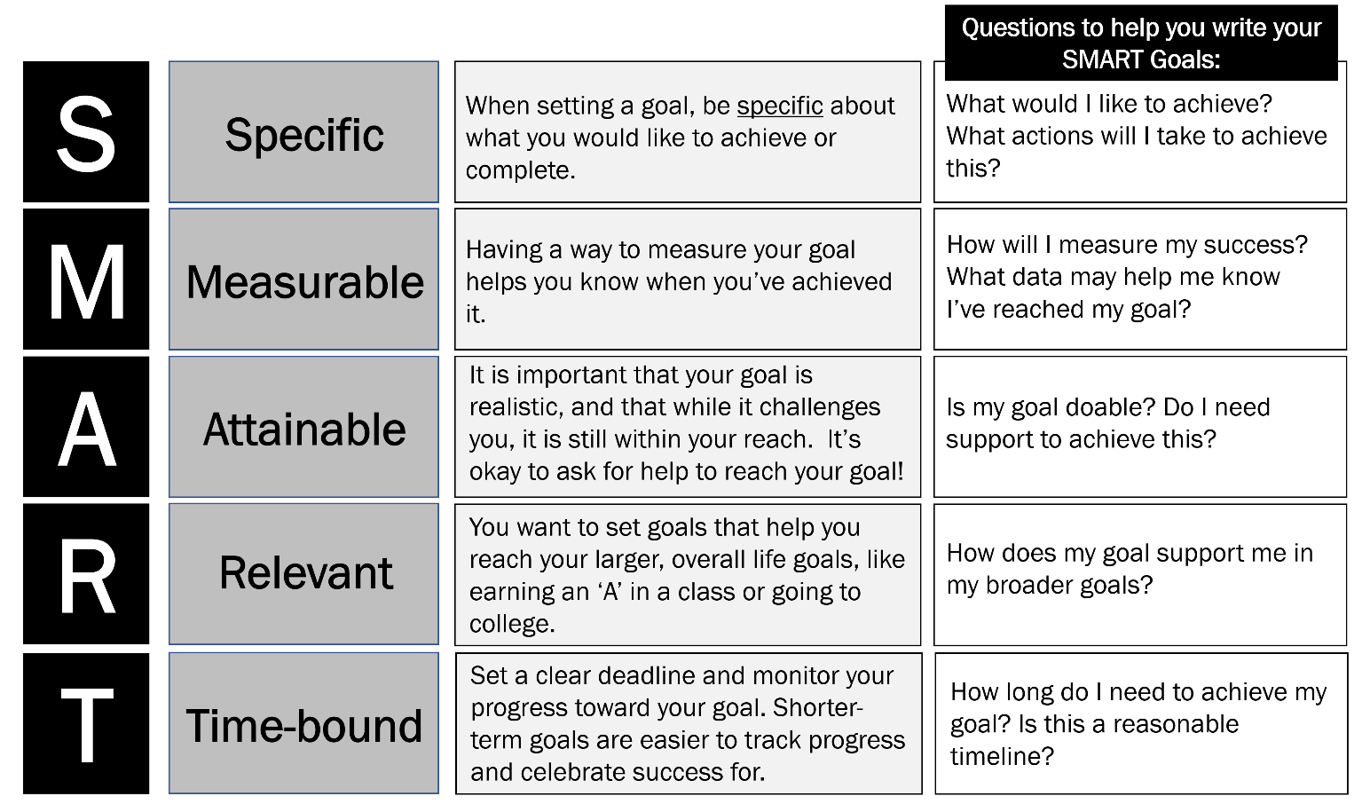
Turn back to Juan’s goal on p. 1. Where do you see elements of SMART goals reflected in Juan’s goal?
__________________________________________________________________________________________________________________________________________________________________________________________________________________________________________________________________________________________________________________________________________________________________________________________________________________________________________________________________

Managing Social Media – Setting SMART Goals
- Think back over your previous learning from Lessons D and E. Consider your reflections on different aspects of social media use: the amount of time you spend on social media, what you enjoy about social media, ways to curate your social media feeds, passive vs. active use, what makes you frustrated about social media.
Pick two topics to write SMART Goals for. Explain why you chose those topics.

Directions: In the spaces below, write 2 SMART Goals you have for yourself around social media use.
SMART Goal #1: __________________________________________________________________________________________
__________________________________________________________________________________________________________________________________________________________________________________________________________________________________________________________________________________________________________________________________________________________________________________________________________________________________________________________________
Use the checklist below to evaluate your action step before you write the next one. If you find you haven’t met the criteria, revise your action step.
Is your action step…
___ Specific? Does it include specific actions you’d like to achieve (ex: limit use of TikTok)?
___ Measurable? Did you include data that will help you measure your success (ex: 25 min in the morning)?
___ Attainable? Is this goal actually doable (ex: if you use social media every day, setting a goal to only use it on Saturdays is likely unattainable)?
___ Relevant? Does this goal support you in your broader goals?
___ Time-bound? Did you include an end date to reevaluate your progress and celebrate success?

Managing Social Media – Setting SMART Goals
SMART GOAL #2: __________________________________________________________________________________________
__________________________________________________________________________________________________________________________________________________________________________________________________________________________________________________________________________________________________________________________________________________________________________________________________________________________________________________________________
Use the checklist below to evaluate your action step. If you find you haven’t met the criteria, revise your action step. Is your action step…
___ Specific? Does it include specific actions you’d like to achieve (ex: limit use of TikTok)?
___ Measurable? Did you include data that will help you measure your success (ex: 25 min in the morning)?
___ Attainable? Is this goal actually doable (ex: if you use social media every day, setting a goal to only use it on Saturdays is likely unattainable)?
___ Relevant? Does this goal support you in your broader goals?
___ Time-bound? Did you include an end date to reevaluate your progress and celebrate success?

