Name: __________________________ Date: __________________
Homeroom: _____________________
How to Care for Yourself And Others

Directions: Read the following excerpt from Give and Take by Adam Grant’s, which explores the science people who live compassionate lives, and answer the questions that follow.
“Compassion is a virtue that can change the world for the better. However, if people are too compassionate and giving of their time, they can end up exhausted and unproductive. Recent research in positive psychology suggests that the most successful people who score high in measures of compassion do not give without limits. They balance their love for helping others with regular forms of self-care. They’re giving, but careful not to overextend themselves along the way. They’re as kind to themselves as they are to others.

When concern for others is accompanied by a healthy dose of concern for the self, compassionate people are less likely to burn out—and they’re better positioned to flourish. They consciously choose the recipients of their compassion, the resources they have available, and their level of energy based on what will support the well-being of themselves and others. Striking this balance will ensure that you can have the energy and will to help others when they need it most.”
Stop and Jot:
- What happens when compassionate people are too generous with their time and resources? Why?
____________________________________________________________________________________________________________________________________________________________________________________________________________________________________________________________
- What does Grant find is true about people who are both compassionate and successful in life?
__________________________________________________________________________________________________________________________________________________________________________
How to Care for Yourself And Others (Continued)
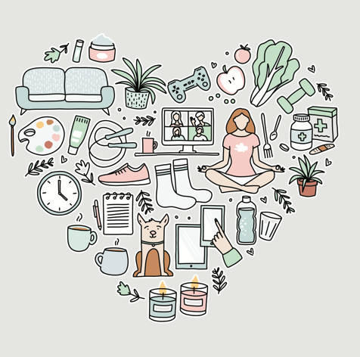
Self-care is any activity that we do deliberately in order to take care of our mental, emotional, and physical health. Although it’s a simple concept in theory, it’s something we very often overlook, especially when we’re busy trying to keep up with our lives, or to help out our friends and family. Good self-care is key to improved mood and reduced anxiety. It ensures that you are able to bring the best version of yourself for others.

How do you know when you’re in need to pause and engage in self-care? This question might seem obvious, but when we get busy with our day-to-day responsibilities, it’s so easy to lose sight of how we’re feeling or to be alert to warning signs that we may need to pause, relax, and recharge. Here are some of the most common signs that you’re in need of some self-care.

Physical Warning Signs:  - Increased difficulty with falling asleep  - Frequent headaches or muscle pain  - Changes in appetite  - Dizziness  - Frequent colds or illnesses  - Feeling tired and drained most (even after you get a good night’s rest)of the time | Emotional Warning Signs:  - A loss of motivation  - Increasingly cynical or negative outlook  - Feelings of failure, self-doubt, helplessness  - Feeling trapped or defeated  - Feeling alone or isolated from the world  - Increased sensitivity to criticism from others

Stop and Jot: Which of these warning signs do you experience when you don’t take care of yourself?
________________________________________________________________________________________________________________________________________________________________________________________________________________________________________________________________________

How to Care For Yourself And Others (Continued)

Below are lists of simple self-care activities that author Steven Covey recommends for teens who want to nourish these four areas of their life. The goal shouldn’t be to try all of them, but rather to experiment with a few so you can figure out which of these you can fall back on again and again.

Directions: Circle two self-care activities you’ll commit to trying this week. Then add one of your own for each area.
Body  - Make a nice meal or snack for yourself  - Gently brush your hair  - Wash your hands and face with warm water while paying attention to the sensations  - Lay down in bed to relax for 15 minutes (tip: leave or turn off your smartphone)  - Have a bubble bath or long shower  - Go out for a jog  - Get a good night’s rest  - Take a walk outside in your neighborhood  - _____________________________________ | Brain  - Read or listen to the news every day  - Attend a lecture on an interesting topic  - Watch an interesting documentary  - Visit a library or bookstore  - Research your ancestors/create a family tree  - Write a story, poem, or song  - Play challenging board games  - Visit a museum  - Learn to play a musical instrument  - Read a good book  - _____________________________________
Heart  - Put on some relaxing music  - Watch your favorite movie or TV show  - Pet your dog or cat  - Write a list of five things you’re grateful for  - Hug yourself or someone else  - Call or video chat with a friend  - Pet your dog or cat  - Write and deliver a “thank you” letter  - _____________________________________ | Inner Self  - Write in a personal journal  - Draw  - Write a poem or song  - Meditate  - Listen to a song that makes you smile  - Play a musical instrument  - Sit outside to enjoy the sunshine  - Look at beautiful artwork  - _____________________________________

Stop and Jot: Identify two self-care activities that you’ll commit to trying this week:

Reflection Questions for How to Care for Yourself And Others
Directions: In your neatest handwriting and in complete sentences, answer the following questions.

- Using what you learned from the readings, explain why engaging in self-care can ultimately benefut the people around you.

_______________________________________________________________________________________

_______________________________________________________________________________________

_______________________________________________________________________________________

- Describe a time when you became so focused on helping someone else that you forgot to also take care of yourself. What were the consequences?
____________________________________________________________________________________________________________________________________________________________________________________________________________________________________________________________________________________________________________________________________________________________
- Using what you learned today, how might you handle this situation differently? What could you do instead?
____________________________________________________________________________________________________________________________________________________________________________________________________________________________________________________________________________________________________________________________________________________________

Stamp Your Learning for How to Care for Yourself And Others
Directions: Answer the following questions in complete sentences.
- Booker T. Washington once wrote: “Those who are happiest are those who do the most for others.” Do you agree? Why?

____________________________________________________________________________________
____________________________________________________________________________________
____________________________________________________________________________________
____________________________________________________________________________________

- In one artful sentence, explain why practicing self-care can help you live a more compassionate life.

____________________________________________________________________________________________________________________________________________________________________________________________________________________________________________________________

Give and Take: Why Helping Others Drives Our Success by Adam Grant (Page
overextend: to try to do too much
flourish: to do very well

