Name: __________________________ Date: __________________
Homeroom: _____________________
Peer-to-Peer Support

Directions: Read the following case study and answer the questions that follow.
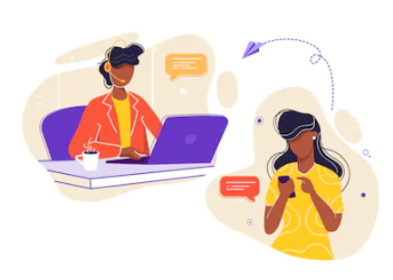
Being an adolescent can be hard sometimes. When your best friend started hanging out with older kids and making questionnable choices, you weren’t sure what to do. You wanted someone your own age to talk to and ask for advice because they could relate. You didn’t want to betray your friend’s trust, so finding someone anonymous was important.
After some light research, you found an online message board supported by your community center, it was exactly what you needed. Adolescents, like you, post messages about their problems “on the board” and other teens respond with advice; no names, just support.
The support your received was so helpful, you decide to pass it on and start volunteering at the community center’s message board. Today, you’ve been assigned to reply to any posts dealing with peer pressure.
You start reading the first post:
“I do things I don’t like with my friends, but I have to stay friends with them.”

Hey, there’s something I want to talk about, and I can’t ask any of my friends because it’s about my friends.
At school, I hang out with 5 other girls. We do everything together. But I don’t want to stay friends with them anymore because I break rules when I’m with them. I end up doing stupid stuff I wouldn’t normally do, or even like want to do just because my friends are doing it. I don’t have any choice. I have to act cool.
The girls don’t know that I don’t want to be friends with them or that I just go along with them all the time. If I tell them I want to be friends with other girls, they’re just going to call me names and tell me I’m a loser.
It’s probably better for me to just stay friends with these same girls because if I want to be friends with some other girls, I don’t know how to tell them I want to be their friend, and they may not even like me anyway. I feel like I want to be friends with other people, but it would just cause more problems.
I’m really confused.

Stamp Your Learning for Peer-to-Peer Support
Directions: In your neatest handwriting and in complete sentences, draft a response to the message board post.

Here are some suggestions about topics you have already read about and learned in earlier lessons, to ensure an appropriate response:
Be sure to include: | It’s helpful to: | It’s best to avoid:
- Suggested next step(s)  - Evidence (e.g. facts about the brain, knowledge about types of pressure, etc.) to support your suggestion  - Purpose (Why and how is your suggestion going to help?) | - Offer empathy  - Relate to their experience  - Relate to their feelings  - Show understanding  - Offer hope  - Encourage them to be brave | - Being too bossy (e.g. using “must” or “have to”)  - Judging their feelings or experience  - Suggesting the problem is too challenging to be solved

- Use the space below to plan your response.
Suggested Next Step(s) | Evidence | Purpose

Stamp Your Learning for Peer-to-Peer Support (Continued)
- Write your response to the message board post on the lines below.

____________________________________________________________________________________________________________________________________________________________________________________________________________________________________________________________________________________________________________________________________________________________
____________________________________________________________________________________________________________________________________________________________________________________________________________________________________________________________________________________________________________________________________________________________
________________________________________________________________________________________________________________________________________________________________________________________________________________________________________________________________________________________________________________________________________________________________________________________________________________________________________________________________________________________________________________________________________________________________________________________________________________________________________________________________________________________________________________________
__________________________________________________________________________________________________________________________________________________________________________________________________________________________________________________________________________________________________________________________________________________________________________________________________________________________________________________________________________________________________________________________________________

anonymous: not named; made or done by someone unknown

