Name: __________________________ Date: ____________
Homeroom: ______________________
Integrity in “The Wolf and the Lion”
Directions: Read the context and fable below, and then answer the questions that follow.

What is a Fable?
Fables are stories that are supposed to teach readers a lesson and are NOT supposed to be realistic. This story is no different. There were no lions near Rome, even in ancient times and if there were a hungry lion would probably kill a human no matter what.
So, as you read, consider why the author created this story, with these characters and events? Why does he start with the main character as a slave?

“The Wolf and the Lion” by Aesop

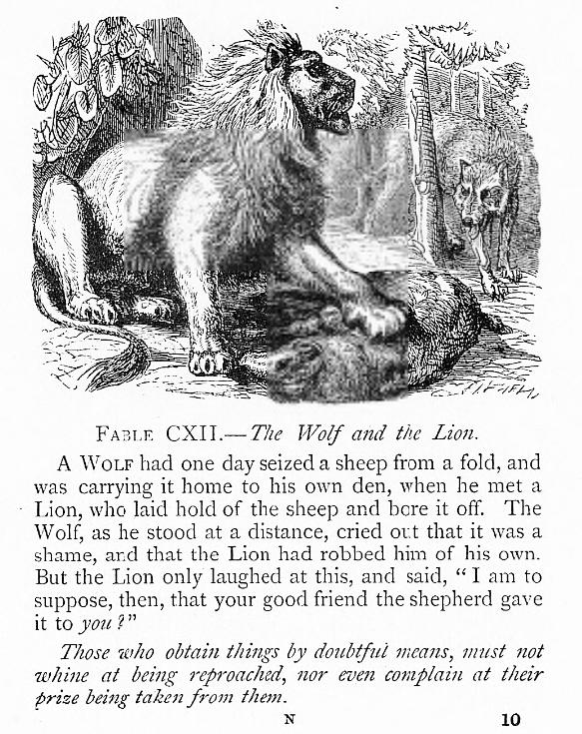
A wolf had one day seized a sheep from a fold, and was carrying it home to his own den, when he met a Lion, who laid hold of the sheep and bore it off. The Wolf, as he stood at a distance, cried out that it was a shame, and the Lion had robbed him of his own. But the Lion only laughed at this, and said, “I am to suppose, then, that your good friend and the shepherd gave it to you?”

Those who obtain things by doubtful means, must not whine at being reproached, nor even complain at their prize being taken from them.

Stop and Jot: Who owns the sheep that the Wolf seizes? How can you tell?
________________________________________________________________________________________________________________________________________________________

Reflection Questions for Integrity in “The Wolf and the Lion”
Directions: In your neatest handwriting and in complete sentences, answer the following questions:

- What does the Wolf accuse the Lion of doing when he sees him?

_____________________________________________________________________________________________________________________________________________________________________________________________________________________________________________________________________
- In your own words, explain what the Lion mean when he tells the Wolf: “I am to suppose, then, that your good friend the shepherd gave it to you?”

_____________________________________________________________________________________________________________________________________________________________________________________________________________________________________________________________________

- Why does the Lion laugh at the Wolf while he says this?
_____________________________________________________________________________________________________________________________________________________________________________________________________________________________________________________________________
- Paraphrase the meaning of the moral or lesson of the story in your own words: “Those who obtain things by doubtful means, must not whine at being reproached , nor even complain at their prize being taken from them.”

_____________________________________________________________________________________________________________________________________________________________________________________________________________________________________________________________________

Reflection Questions for Integrity in “The Wolf and the Lion” (Continued)
- How can you apply the lesson of this fable to your life today?

_____________________________________________________________________________________________________________________________________________________________________________________________________________________________________________________________________

Aesop’s Fables by Aesop
fold: an area that is closed off where sheep can be kept
laid hold: to take and hold (something)
bore: to carry from one place to another (past tense of ‘bear’)
shepherd: a person who raises and takes care of sheep
means: resources or ability to do something
reproach: to express disapproval or disappointment

