Name: __________________________ Date: __________________
Practicing Gratitude
Objective: To explore some approaches to keeping a gratitude journal.

- Make a list of 5 people, actions, or things you’re grateful for this week. Keep the descriptions brief – each one should be a sentence or just a few words (e.g., “my friends,” or “the meal my dad made last night”).

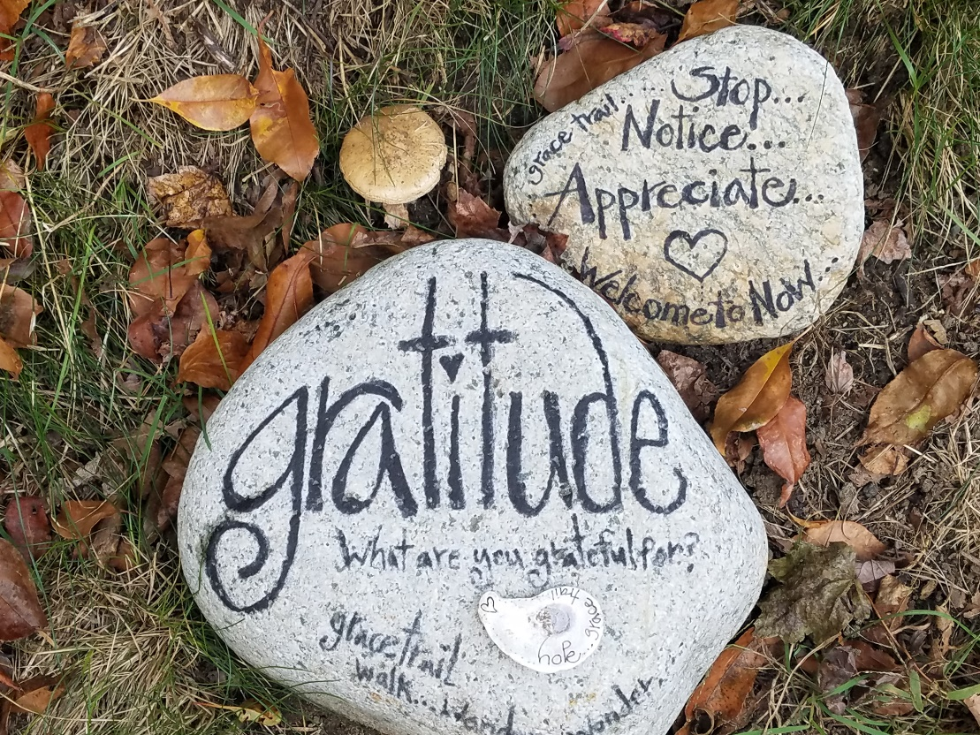

Apply Your Learning for Practicing Gratitude
- Dr. Robert Emmons, a psychology professor and researcher at the University of California, Davis, has studied how practicing gratitude can improve our mental health. One of the most common ways to practice gratitude is by keeping a gratitude journal. Dr. Emmons has found a few important practices that can make gratitude journals much more effective. Read his tips below.
Tips for Keeping a Gratitude Journal
Jason Marsh

- Tip #1: Don’t just go through the motions. Research suggests that journaling is more effective if you first make the conscious decision to become happier and more grateful. Your own attitude is a most powerful motivator—harness it for good!

- Tip #2: Go for depth over breadth. Elaborating in detail about just one thing for which you’re grateful carries more benefits than a superficial list of many things.

- Tip #3: Get personal. Focusing on people to whom you are grateful has more of an impact than focusing on things for which you are grateful.

- Tip #4: Try subtraction, not just addition. One effective way of stimulating gratitude is to reflect on what your life would be like without certain blessings, rather than just tallying up all those good things.

- Tip #5: Savor surprises. Try to record events that were unexpected or surprising, as these tend to elicit stronger levels of gratitude.

- Tip #6: Don’t overdo it. Writing occasionally (once or twice per week) is more beneficial than daily journaling. In fact, one study by Lyubomirsky and her colleagues found that people who wrote in their gratitude journals once a week for six weeks reported boosts in happiness afterward; people who wrote three times per week didn’t. “We adapt to positive events quickly, especially if we constantly focus on them,” says Dr. Emmons. “It seems counterintuitive, but it is how the mind works.”

What might intrigue you about keeping a gratitude journal? What might you find challenging?
________________________________________________________________________________________________________________________________________________________________________________________________________________________________________________________________________________________________________________________________________________________________________

Apply Your Learning for Practicing Gratitude (Continued)
- Consider Tip #3 – “Get personal.” Head back to your list on page 1. If you listed a thing or action, edit your bullet to include who made that happen. For example, if you wrote down something like “my good grade on my quiz,” you might edit it to say, “my friend who helped me study for my quiz which led to me getting a good grade.”

- Consider Tip #6 – “Don’t overdo it.” Does this advice surprise you? Explain.
________________________________________________________________________________________________________________________________________________________________________________________________________________________________________________________________________________________________________________________________________________________________________
- Let’s practice Tip #2 – “Go for depth over breadth.” Choose one of the bullets you listed on page 1 and write more about your gratitude. Try to push yourself to write 4-5 lines.
Gratitude in Depth

Stamp Your Learning for Practicing Gratitude
- Step back and reflect. How did practicing gratitude make you feel? What was easy for you? What was more difficult for you?
__________________________________________________________________________________________________________________________________________________________________________________________________________________________________________________________________________________________________________________________________________________________________________________________________________________________________________________________________
- How might you make gratitude a normal practice for you? Be specific.
__________________________________________________________________________________________________________________________________________________________________________________________________________________________________________________________________________________________________________________________________________________________________________________________________________________________________________________________________

Jason Marsh, “Tips for Keeping a Gratitude Journal,” Greater Good Magazine, November 17, 2011, https://greatergood.berkeley.edu/article/item/tips_for_keeping_a_gratitude_journal.

