**Name**: __________________________ **Date:** __________________

**Homeroom**: _____________________

***Integrity in “The Emperor’s Seed”***

**Directions:** Read the context and fable below, and answer the questions that follow.

|  |
| --- |
| **What is a Fable?**  Fables are stories that are supposed to teach readers a lesson and are NOT supposed to be realistic. This story is no different. There were no lions near Rome, even in ancient times and if there were a hungry lion would probably kill a human no matter what.  So, as you read, consider why the author created *this* story, with *these* characters and events? Why does he start with the main character as a slave? |

There was once an Emperor from China who had no children and needed to choose a successor[1].

Thousands of children from across the kingdom came to the palace and were surprised when the Emperor exclaimed that he was going to choose one of them.  He gave them all a seed.  They were to go home to their villages, plant the seed in a pot and tend[2] it for a year.  When they return in a year, the Emperor would judge their efforts and choose his successor.

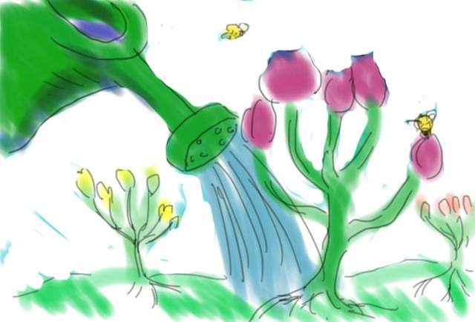

[This Photo](https://www.flickr.com/photos/jonnygoldstein/3883581955) by Unknown Author is licensed under [CC BY](https://creativecommons.org/licenses/by/3.0/)

There was a boy named Ling who received his seed and returned to his village. His mother helped him to choose a pot and put some soil into it.

Ling watered his pot every day.

Once a week, the children of the village would get together to compare their plants. After a few weeks, there were signs of life in all but Ling’s pot.

The weeks passed and Ling continued to water his pot every day.

After a few months, the pots really came to life. Some had trees starting to grow, some had flowers, and some had leafy shrubs. Poor old Ling still had nothing growing in his pot, leading the other children to make fun of him.

***Integrity in “The Emperor’s Seed”* (Continued)**

Ling continued to water his pot every day.

A year passed and it was time to return to the palace to show what had grown and decide on the new heir[3].

Ling was nervous as his pot still showed no signs of life.

“What if they punish me?” Ling asked his mother. “They won’t know that I’ve watered it every day, they’ll think that I’m lazy.”

His mother looked him in the eye and explained that whatever the consequences were, he had to return and show the Emperor his empty pot.

|  |
| --- |
| **Stop and Jot:** What are some of the consequences that Ling is worried that he will face if he brings an empty pot to the Emperor?  ________________________________________________________________________________________  ________________________________________________________________________________________  ________________________________________________________________________________________ |

Ling and the other children entered the palace gates. By now, some of the plants were looking magnificent and the children were wondering which one the Emperor would choose.

Ling was embarrassed as other children looked at his lifeless pot and scoffed[4].

The Emperor came out and started to make his way through the crowd, looking at the many impressive trees, shrubs and flowers that were on display. The boys all puffed their chests out and tried to look as regal[5] as possible, hoping that they would be chosen as the heir to the empire.

Then the Emperor came to Ling.  He looked at the pot then he looked at Ling.

“What happened here?” He asked.

“I watered the pot every day, but nothing ever grew.” Ling muttered[6] nervously.

***Integrity in “The Emperor’s Seed”* (Continued)**

Then he grumbled something to himself and moved on.

After a few hours, the Emperor finally finished his assessment.

He stood in front of the children and congratulated them on their efforts.

“Clearly, some of you desperately want to be Emperor and would do anything to make that happen, but there is one boy that I would like to point out as he has come to me with nothing. Ling, come here please.”

“Oh no,” thought Ling.  He slowly sauntered[7] to the front of the group, holding his barren[8] pot.

The Emperor held up the pot for all to see and the other children laughed. Then the Emperor continued, “A year ago, I gave you all a seed. I told you to go away, plant the seed and return with your plant. The seeds that I gave you all were boiled until they were no longer viable and wouldn’t grow, but I see before me thousands of plants and only one barren pot. Integrity and courage are more important values for leadership than proud displays, so Ling here will be my heir.”

|  |
| --- |
| **Stop and Jot:** In the Emperor’s eyes, how has Ling has shown “integrity” and “courage?”  ________________________________________________________________________________________  ________________________________________________________________________________________  ________________________________________________________________________________________ |

**Reflection Questions for *Integrity in “The Emperor’s Seed”***

**Directions:** In your neatest handwriting and in complete sentences, answer the following questions:

1. Why did the Emperor choose Ling? Use evidence from the text to support your answer.

____________________________________________________________________________________________________________________________________________________________________________________________________________________________________________________________________________________________________________________________________________________________

1. What would you have done if your seed didn’t grow? Why?

____________________________________________________________________________________________________________________________________________________________________________________________________________________________________________________________________________________________________________________________________________________________

**Stamp Your Learning for *Integrity in “The Emperor’s Seed”***

**Directions:** Answer the following questions in complete sentences.

1. In one artful sentence, explain what the lesson of this fable is.

_____________________________________________________________________________________________________________________________________________________________________________________________________________________________________________________________________

1. Name two ways that you could apply this lesson to your own life.

____________________________________________________________________________________________________________________________________________________________________________________________________________________________________________________________________________________________________________________________________________________________

1. **successor**: a person who has a job or position after someone else
2. **tend**: to take care of something
3. **heir**: a person who has the right to become a king when the person holding it dies
4. **scoff**: to laugh at someone in a way that shows a lack of respect
5. **regal**: suitable for a king or queen
6. **mutter**: to speak quietly so that it is difficult for others to hear what you say
7. **saunter**: to walk in a slow manner
8. **barren**: not having many plants