Name: __________________________ Date: __________________

The Bystander Effect
Objective: Explain what the bystander effect is and the psychological factors that lead to it.

Imagine the following scenario: You’re in a room at school, and you see a student you don’t know fall and have what looks like a seizure. They’re struggling on the floor.

- You are alone with the student. What do you think you would do in this situation, and why?
________________________________________________________________________________________________________________________________________________________________________________________________________________________________________________________________________________________________________________________________________________________________________

- If there were other people in the room with you, would you react differently? Why or why not?
________________________________________________________________________________________________________________________________________________________________________________________________________________________________________________________________________________________________________________________________________________________________________

The Bystander Effect (Cont’d)

The Bystander Effect – Study 1

In a study conducted by psychology researchers Bibb Latane and John Darley, a group of college students at New York University were called into a room—sometimes alone, sometimes as part of a group. The students were asked to talk about what their college experience had been like, and while a student spoke, one of the researchers, posing as a student, pretended to have a seizure.

Researchers observed student reactions: when the student believed they were the only witness, they reported the emergency or tried to help 85% of the time. However, when the student thought others were witnessing the event, only 31% of the students in the study intervened to help in some way.

- What strikes you about this study?
________________________________________________________________________________________________________________________________________________________________________________________________________________________________________________________________________________________________________________________________________________________________________

- Why might students have been less likely to intervene as the number of perceived witnesses increased?
________________________________________________________________________________________________________________________________________________________________________________________________________________________________________________________________________________________________________________________________________________________________________

- How might this study help us understand or appreciate acts of courage?
________________________________________________________________________________________________________________________________________________________________________________________________________________________________________________________________________________________________________________________________________________________________________

The Bystander Effect (Cont’d)

The Bystander Effect – Study 2

The study summary you read above illustrates what psychologists call the bystander effect, or the “psychological phenomenon where individuals are less likely to help or intervene due to the ambiguity of the situation,” multiple people present witnessing the situation, and “the social pressure of others’ inaction.”

In another study, Latane and Darley set up a similar situation, but instead of a medical emergency, they used the threat of a fire. They recruited a group of study participants to answer a survey. They put study participants into one of three scenarios – in the first, the subjects were by themselves, in the second, the subjects were with two other participants, and in the third, the subjects were with two researchers who were pretending to be study participants.

In each scenario, as the study subjects were completing a questionnaire, smoke began to fill the room. Latane and Darley observed the following reactions from the study participants, which varied dependent on who else was in the room with them:

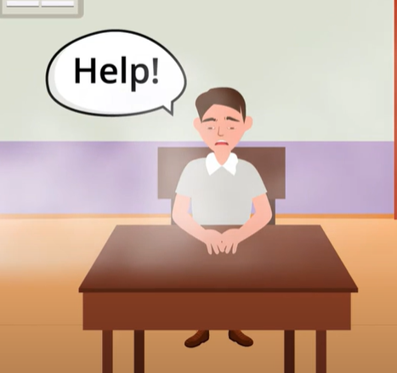 | 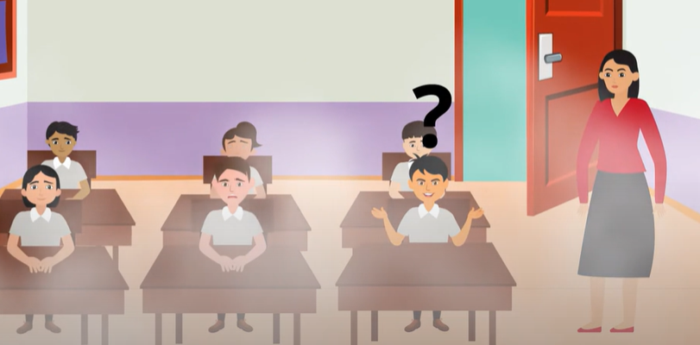 | 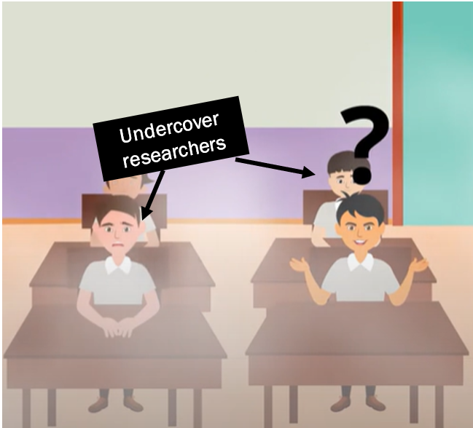
Scenario one:  One study participant in the room by themselves (solo) | Scenario two:  Study participants in small groups | Scenario three:  Participants in small groups with undercover researchers
75% of study participants left the room to report the smoke | 38% of participants left to report the smoke | 10% of participants left the room to report the smoke

Ambiguity = lack of clarity

The Bystander Effect (Cont’d)
Watch a video of a replication of the study here: https://www.youtube.com/watch?v=KE5YwN4NW5o
*Note that confederates are researchers who are pretending to be participants.
- Watch the video and try to imagine what the participant is thinking. Jot your notes in the chart below:
Solo Participant | Participant with Confederates

- Imagine yourself in the situation you just watched. In what way(s) might you act similarly to the participants? In what way(s) might you act differently? Explain your response.
________________________________________________________________________________________________________________________________________________________________________________________________________________________________________________________________________________________________________________________________________________________________________

The Bystander Effect (Cont’d)
The Bystander Effect (Continued)

You likely thought something like, “There is no way I would not seek help!” if you witnessed a person having a seizure or a room filling with smoke. However, we’ve all experienced the bystander effect, or probably will at some point, since it is a psychological reaction.

Psychologists often discuss the bystander effect in terms of three major factors.

- Diffusion of responsibility: As the number of other witnesses, or bystanders, increases, the likelihood of intervention by an individual decreases. This is because we think other people will jump in and help. In the second and third scenario, where three participants were together, they were each thinking that someone else would help.

- Ambiguity of the situation: The lack of clarity of what is happening can cause bystanders to not intervene. Sometimes, we have a hard time discerning if something is a true emergency or whether someone really needs help
When we can’t figure out if an event is serious or life-threatening, we look to other bystanders to determine what our own reaction should be: if it’s serious, wouldn’t the other people in the room react?

- Social pressure from the inaction of others: Most people want to be perceived as behaving in a socially acceptable way. When others aren’t reacting to a situation that might be serious, we can feel social pressure to limit our reactions, so we do not look uncool or overly anxious.

- Recall the example on p. 2: only 31% of students tried to help a peer experiencing a seizure when there were other witnesses around. How does diffusion of responsibility explain this?
________________________________________________________________________________________________________________________________________________________________________________________________________________________________________________________________________________________________________________________________________________________________________

- Consider that social pressure is a factor at play in the bystander effect. How might social pressure complicate decisions to act courageously? Hint: think about this part of our definition of courage: “deciding to act in a manner that incurs risk.

________________________________________________________________________________________________________________________________________________________________________________________________________________________________________________________________________________________________________________________________________________________________________
Stamp Your Learning for The Bystander Effect
While it might be hard to learn about the bystander effect and how susceptible everyone is to it, the good news is that one of the most effective ways to stop being a bystander is to understand the bystander effect and recognize when it’s happening.
- Explain what the bystander effect is in your own words. Strive to use the word ‘courage’ in your response.
________________________________________________________________________________________________________________________________________________________________________________________________________________________________________________________________________________________________________________________________________________________________________
- Describe the role that social pressure can play in the bystander effect.
________________________________________________________________________________________________________________________________________________________________________________________________________________________________________________________________________________________________________________________________________________________________________

Scott, Elise S., David A. Ross, and Elizabeth Fenstermacher. “Stand by or Stand up: Exploring the Biology of the Bystander Effect.” Biological Psychiatry 90, no. 2 (July 2021). https://doi.org/10.1016/j.biopsych.2021.05.007.
American Psychology Association. n.d. “Bystander Intervention Tip Sheet.” Accessed September 15, 2024. https://www.apa.org/pi/health-equity/bystander-intervention.
Latane, B., & Darley, J. M. (1968). Group inhibition of bystander intervention in emergencies. Journal of Personality and Social Psychology, 10(3), 215–221. https://doi.org/10.1037/h0026570
“The smoke filled room study,” markmcdermott, September 15, 2007, educational video, 0:00 to 2;07, https://www.youtube.com/watch?v=LYENi9padNg.
“The Smoky Room Experiment: Trust Your Instincts – Psychology Experiments Series,” United 4 Social Change, February 28, 2021, educational video, 0:00 to 0:39, https://www.youtube.com/watch?v=KE5YwN4NW5o

