Name: __________________________ Date: __________________
Negative Impacts of Social Media – Part 2

Objective: Reflect on the negative impacts of social media and how it might support avoiding interacting with other people.

Directions: If you completed Lessons A and B already, you have seen the diagram below. If you did not yet, these are the results from a study conducted by the Pew Research Center. The study surveyed 743 teenagers, aged 13-17, in 2018, about their cell phone, video game, and social media use. As a result of the study, the following graphic was developed.
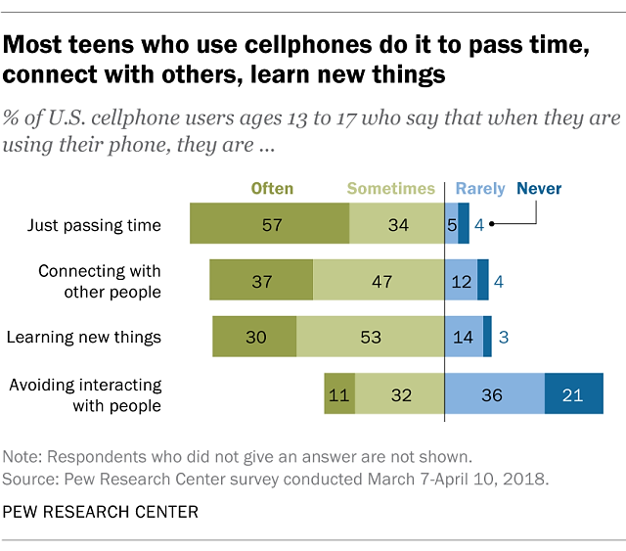
Focus on the category of “avoiding interacting with other people.”
- Does this category resonate with you? How often do you find yourself using social media platforms to “avoid interacting with other people”? Are there specific settings in which you find yourself doing this (e.g., when you first arrive at school and your friends aren’t there yet, when with family, etc.)?
____________________________________________________________________________________________________________________________________________________________________________________________________________________________________________________________________________________________________________________________________________________________________________________________________________________________________________________________________________________________________________________________________________________________
Negative Impacts of Social Media – Part 2 Reflection Questions (Continued)
Directions: With your reflection on using social media to avoid interacting with others in mind, read the following excerpt from an interview of Dr. Anne Marie Albano, the co-clinical director of the Youth Anxiety Center at New York Presbyterian, professor of medical psychology in psychiatry at Columbia University Vagelos College of Physicians and Surgeons, and founder of the Columbia University Clinic for Anxiety and Related Disorders.
Underline anything that surprises you. Then answer the questions that follow in 3-4 sentences.

Is Social Media Threatening Teens’ Mental Health and Well-being?

Interview with Anne Marie Albano, Ph.D., Health Matters
How is social media impacting young people’s mental health?
There are youth who may have a tendency to spend more time online and reduce their real, face-to-face contact with other folks. When an individual is not engaging in the world in a healthy way – interacting with others, managing themselves in challenging situations, whether it’s in classes or speaking up in class, going on interviews, dealing with conflict with peers – and instead increase their online presence, this can exacerbate their feelings of alienation, hopelessness, isolation, anxiety, and depression.
Can you describe how the “culture of comparison” mindset can be particularly damaging?
The “culture of comparison” mindset describes how people compare themselves to other people on social media, sometimes forgetting that images on social media can be faked or unrealistically presented.
Any kid who is prone to concerns about their self-image and who they are, who is anxious about fitting in or what other people think about them, will inevitably compare themselves to the number of likes, friends, or followers other people have when they go online. They are looking at these sites through a negative lens of, “I’m never going to be as good as these people.” That mindset puts them at risk of increasing depression and isolation, and these are all factors that can contribute to feelings of suicide, especially when bullying gets added to the mix.
How much time is too much time on social media?
According to a Pew Research study, 45% of teens admit that they are online “almost constantly.” So, if kids are online less than a couple of hours a day, they’re doing really well. But for those who spend three to six hours or more a day, that’s when they’re getting into iffy territory. It’s interfering with the time they could be spending with other people or doing things that help with their developmental growth, like engaging in school and extracurricular activities.

Negative Impacts of Social Media – Part 2 Reflection Questions (Continued)
Engaging in the world around you and having social interaction with others help to develop a sense of being part of the community and doing things that enhance your feelings of competency around other people. This engagement is extremely beneficial for your personal growth and development, and it doesn’t happen when you’re online.
Why is social isolation dangerous?
Because we live in a social world. It’s healthy for an individual to have at least one or two friends who listen to you, whom you can engage with, and have fun with. And isolation, especially isolation where you are in a world of watching Netflix, scrolling Instagram, or gaming, will increase anxiety and this sensation of unreality, which can give you a false sense of the way the world really works. If you stay online, you may get a false sense that the world is too hurtful or dangerous. A kid might feel, “There’s nothing out there for me. I can’t do anything. I might as well just lose myself in another season of whatever show this is.” And that’s not healthy. You don’t become a productive, contributing member of society.

- Consider the interview you just read.
- Which parts of this interview surprised you?
__________________________________________________________________________________________________________________________________________________________________________________________________________________________________________________________________________________________________________________________________________________________________________________________________________________________________________________________________

- How does reading this interview impact your reflections on the negative impacts of social media? Explain.
__________________________________________________________________________________________________________________________________________________________________________________________________________________________________________________________________________________________________________________________________________________________________________________________________________________________________________________________________
- Are there any parts of this interview you disagreed with? Why or why not?
__________________________________________________________________________________________
__________________________________________________________________________________________
__________________________________________________________________________________________
__________________________________________________________________________________________
- Have you ever felt social isolation when using social media? Have you witnessed this in friends?
_________________________________________________________________________________________
_________________________________________________________________________________________
_________________________________________________________________________________________
_________________________________________________________________________________________
_________________________________________________________________________________________

- How does this interview relate to your own reflection of using social media to avoid interacting with others?

_________________________________________________________________________________________
_________________________________________________________________________________________
_________________________________________________________________________________________
_________________________________________________________________________________________
_________________________________________________________________________________________

Stamp Your Learning for Negative Impacts of Social Media – Part 2
Directions: Below you’ll see the same sentence starter for each sentence followed by a different conjunction (because, but, or so). Complete each sentence taking careful note of how the conjunction changes the end of your sentence.

- Social media can be used to avoid interacting with others because…
__________________________________________________________________________________________
__________________________________________________________________________________________
__________________________________________________________________________________________

- Social media can be used to avoid interacting with others but…
__________________________________________________________________________________________
__________________________________________________________________________________________
__________________________________________________________________________________________

- Social media can be used to avoid interacting with others so…
__________________________________________________________________________________________
__________________________________________________________________________________________
__________________________________________________________________________________________

Katherine Schaeffer, “Most U.S. teens who use cellphones do it to pass time, connect with others, learn new things,” Pew Research Center, August 23, 2019, https://www.pewresearch.org/fact-tank/2019/08/23/most-u-s-teens-who-use-cellphones-do-it-to-pass-time-connect-with-others-learn-new-things/
“Is Social Media Threatening Teens’ Mental Health and Well-being?” Health Matters, accessed May 12, 2022, https://healthmatters.nyp.org/is-social-media-threatening-teens-mental-health-and-well-being/

