Name: __________________________ Date: __________________
Homeroom: _____________________
It’s Cooler to be Uncool

Stop and Consider: Would you be more likely or less likely to do something if other kids thought it was “cool”? Why?

________________________________________________________________________________________________________________________________________________________________________________________________________________________________________________________________________________________________________________________________________________________________

Directions: Read the following article and answer the questions that follow.
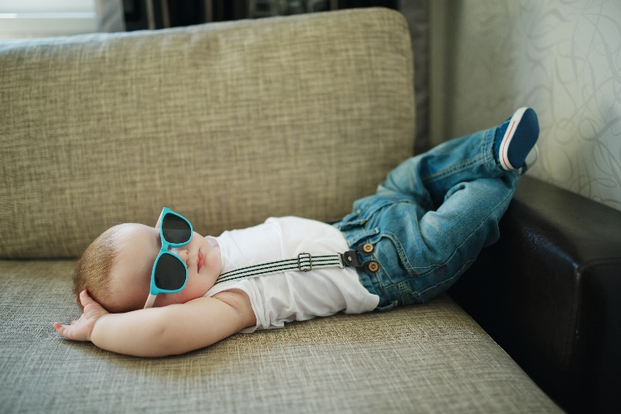
One Study says It’s Cooler to be Uncool
When they grow up, the quiet kids from middle school will rule the world. Or, at least, they’ll live healthier and more productive lives than the "cool" kids will.
A new study looked at 13-year-olds who acted older than other kids their age. These were often seen as the “cool kids.” The study found that these “cool kids” tended to develop problems with unsafe choices and friendships by their early 20s.
Nearly 200 13-year-olds were tracked in the study for 10 years. A variety of behaviors were considered. Among them were how much students valued their popularity, how important appearance was in seeking out friends and if students made unsafe choices.

Popularity Doesn't Equal Social Skills
The researchers found that young teens who acted old for their age were considered popular. But as these “pseudo mature” teens matured, things changed: Their behavior was no longer linked with popularity.
It’s Cooler to be Uncool (Continued)
Instead, they were thought to be less socially skilled than others their age, said Joseph Allen, who led the study. They also had more problems making appropriate and safe choices. Allen said the average “cool” teen, by age 22, compared poorly with the average teen in the study. They had a 45 percent greater rate of problems. They also had a 22 percent greater rate of breaking the law.
Teens are impressed by these kids. Parents are impressed too, "because they think that these pseudo mature kids are on the fast track," Allen said. “These kids are on the fast track," he said, "but it’s really to a dead end." He added, “They are gaining the appearance of maturity." But they are not gaining real maturity.
Researchers suggest that these kids are failing to develop important life skills. They spend so much time trying to seem cool, they don’t develop the skills needed for meaningful friendships.
Stop and Jot: What does the researcher mean when he says “ ‘[‘cool’ teens] are gaining the appearance of maturity’ but they are not gaining real maturity”?
________________________________________________________________________________________________________________________________________________________________________________________________________________________________________________________________________

It's Actually Cooler To Be Uncool
The study followed 86 male and 98 female middle school students for a 10-year period beginning in 1998. There were some surprises, Allen said. It turns out that the sort of older behavior involved is an excellent predictor of future problems and unsafe choices.
Researchers are still following the students to see how they do later in life. All are now in their mid- to late 20s.
One conclusion of the study will be welcome: Students and parents shouldn’t worry too much if their young teens don't seem that popular. If a kid prefers to spend Saturday nights at home watching a movie or reading instead of going out with friends, Allen said, there's no need for concern.
Many "uncool" teenagers, he said, do much better later on than the popular kids do.
It’s Cooler to be Uncool Reflection Questions
Directions: In your neatest handwriting and in complete sentences, answer the following questions:

- In what way does being “cool” in middle school affect students later in life?
a. students are able to develop and maintain meaningful friendships
b. preventing problems with unsafe choices later in life
c. developing appropriate social skills at a younger age than their peers
d. ensuring their parents are still impressed by their popularity

- Write a short paragraph that explains the main idea of the article. Be sure to include at least two pieces of text evidence to support your answer.

____________________________________________________________________________________________________________________________________________________________________________________________________________________________________________________________________________________________________________________________________________________________
_____________________________________________________________________________________________________________________________________________________________________________________________________________________________________________________________________

- After reading the article, would you be more likely or less likely to do something if other kids thought it was “cool”? Has your answer changed? If so, why?

___________________________________________________________________________________________________________________________________________________________________________________________________________________________________________________________________________________________________________________________________________________________________________________________________________________________________________________

Stamp Your Learning for It’s Cooler to be Uncool
Directions: Answer the following questions in complete sentences.
- How has wanting to be popular affected the choices you or someone you know has made in the past?

____________________________________________________________________________________________________________________________________________________________________________________________________________________________________________________________________________________________________________________________________________________________
- Imagine a younger family member or friend asked you about the importance acting “cool” to impress others. What advice might you give them?

____________________________________________________________________________________________________________________________________________________________________________________________________________________________________________________________________________________________________________________________________________________________

- Describe how you will motivate yourself to do the right thing, and not the “cool” thing.

____________________________________________________________________________________________________________________________________________________________________________________________________________________________________________________________________________________________________________________________________________________________

social skills: being able to clearly and respectfully communicate with others
“pseudo mature”: pretending to act like an adult, or someone older
maturity: being fully developed in body and mind
One study says it’s cooler to be uncool by Los Angeles Times, adapted by Newsela staff https://newsela.com/read/coolkids-struggle/id/4371?utm_source=email&utm_campaign=share&utm_medium=web accessed and edited on 1/14/2020

