Name: __________________________ Date: __________________
Homeroom: _____________________
Challenging Negative Self-Talk

Directions: Read the following article and answer the questions that follow.
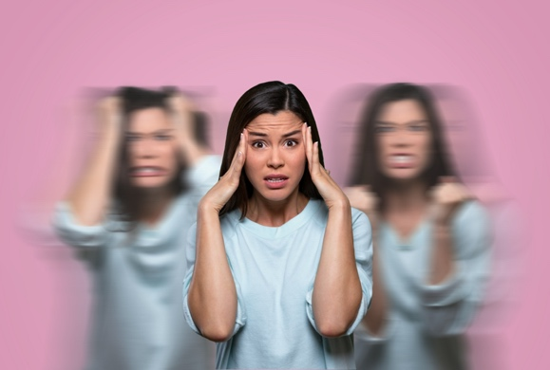
Why do many people—even the most kind and giving of us—struggle to show the same compassion to ourselves? A common cause is negative self-talk, which is the act of saying hurtful (and often unfair) things to oneself, about oneself. As Elizabeth Scott explains in her article “The Toxic Effects of Negative Self-Talk”:
“It can limit your belief in yourself and your own abilities, and your ability to reach your potential. So negative self-talk can not only be stressful, but it can really stunt your success. One large-scale study found that rumination and self-blame over negative events were linked to an increased risk of mental health problems. Focusing on negative thoughts may also lead to decreased motivation as well as greater feelings of helplessness.”

- Stop and Jot: Name two harmful effects of negative self-talk:

_________________________________________________________________________________

_________________________________________________________________________________

Negative self-talk is often caused by thought traps, which you’ll find a description of below:
- All-or-nothing: Looking at things in absolute, black-and-white categories.
- Overgeneralization: Viewing a negative event as a never-ending pattern of defeat.
- Mental filter: Dwelling on the negatives and ignoring the positives.
- Discounting the positives: Insisting that your accomplishments or positive qualities don’t count.
- Jumping to conclusions: You conclude things are bad without any hard evidence.
  - Mind reading: Assuming that people are reacting negatively to you.
  - Fortune-telling: Predicting that things will turn out badly.
- Magnification or minimization: Blowing things way out of proportion or shrinking their importance.
- Emotional reasoning: Reasoning from how you feel (e.g., “I feel like an idiot, so I must be one.”)

Challenging Negative Self-Talk (Continued)

- “Should” statements: Criticizing oneself with “shoulds,” “shouldnts,” “musts,” “oughts,” & “have-tos.”
- Labeling: Instead of saying, “I made a mistake,” you tell yourself, “I’m a failure” or “I’m a loser.”
- Blame: Blaming yourself for something you weren’t entirely responsible for.

- Stop and Jot: Which of these “thinking traps” do you find yourself falling into the most? How do they affect your mood and well-being?

__________________________________________________________________________________

__________________________________________________________________________________

__________________________________________________________________________________

Useful Tip: Double-Standard Technique
Sometimes we may be harder on ourselves than we would be with our loved ones. After you write down your negative thought, ask yourself: “Would I say this to a close friend with a similar problem? Why not? What would I say to him or her?” You will often discover that you operate on a double standard—you have a fairer, more compassionate set of standards that you apply to other people whom you care about than you do for yourself. You beat yourself up relentlessly, as if this would somehow help you achieve perfection or become a better person. One secret to self-compassion is to talk to yourself in the same way as you would talk to a close friend who was upset.

Reflections for Challenging Negative Self-Talk
Part I. Identifying “Thought Traps”
Directions: Decide which “thought trap(s)” could be causing each of these negative thoughts.
Negative Thought | Potential Thought Trap(s)
“I didn’t do as well as I hoped on that math test. I’m just not smart at math.”
“I never get invited to go out places. I must not be fun to hang out with.”
“My best friend still hasn’t called me back. She must be upset with me.”

Part II. Challenging Negative Thoughts
Directions: Identify a negative thought(s) you’ve had and then challenge it in the table below.
Negative Thoughts | Thought Traps  (See list on page 2) |  | Challenging Negative Thoughts  - How could this be a thought trap?  - Is there evidence against this negative thought/interpretation?  - Is there a more positive way to interpret the situation?  - Would I judge a loved one as harshly for making this mistake? What would I say?
Example: I’ll never make friends because I’m unlikable | Example: All-or-nothing thinking; Jumping to Conclusions; Labeling; Blame |  | Example: I may not have friends right now, but I only recently moved here, so I should give myself more time/opportunities to meet people. I know people are capable of liking and valuing me because I had good friends at my old school who showed me that.

Stamp Your Learning for Challenging Negative Self-Talk
Directions: Answer the following questions in complete sentences.
- What situation, relationship, or event tends to trigger your negative self-talk?

____________________________________________________________________________________________________________________________________________________________________________________________________________________________________________________________________________________________________________________________________________________________

- What will you tell yourself the next time you find yourself in this situation so you can overcome the negative thoughts?

____________________________________________________________________________________________________________________________________________________________________________________________________________________________________________________________________________________________________________________________________________________________

“The Toxic Effects of Negative Self-Talk” by Elizabeth Scott. Accessed on 11/20/2020 at https://www.verywellmind.com/negative-self-talk-and-how-it-affects-us-4161304
Excerpted from Ten Days to Feeling Good: The New Mood Therapy by David D. Burns, M.D.
operate: to behave in a particular way
standards: ideas about what’s acceptable or correct
relentless: to continue without becoming weaker

