Name: __________________________ Date: __________________
Encoding Knowledge
Objective: Explain when encoding is helpful and identify strategies to encode knowledge.

Directions: Examine the diagram and the description below and use them to answer the question that follows.
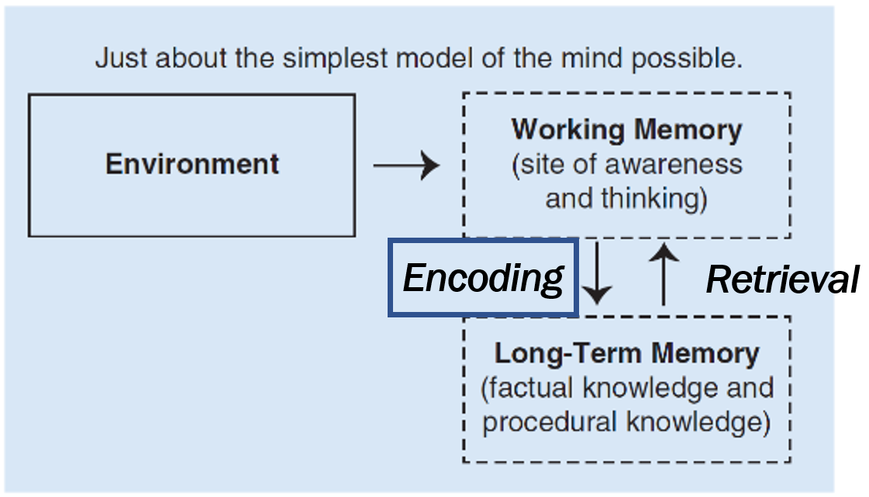
Encoding Knowledge: When and Why?

The graphic above depicts two key learning processes: Encoding and Retrieval. When you initially move something from your working memory into your long-term memory, you are encoding that knowledge. Your study habits can impact the strength of encoding.

In the previous lesson, How Do We Learn, we framed learning as moving our thoughts from working memory into long-term memory. We noted that in order for that to happen, we have to make a connection between new thoughts, knowledge, or skills and prior knowledge—something we already know. Scientifically, this process is called ‘encoding’. When you were a child, you had to memorizing your parent/guardian’s address. Moving that address into your long-term memory is an example of encoding.
Your teacher probably already does many things to help you encode knowledge. As you become more academically independent and mature, you will be expected to do more of the encoding yourself (think: learning from a college lecture). This will also occur as you have more classes where your teacher needs to deliver a significant amount of information and doesn’t have as much time to help you encode.
Another time you’ll need to do some encoding on your own is when you miss class, which means you miss the opportunity to encode information with your classmates.
Psychologist Daniel Willingham often discusses the idea that “what you think about is what you learn.” Below, you’ll find a list of tips to cause yourself to think more deeply about the subject you are learning about and therefore encode the knowledge more deeply in your memory.
These tips are adapted from the advice of Daniel Willingham and Hector Ruiz Martin in his book, Learning to Learn by Knowing Your Brain.

- In your own language, explain encoding.
__________________________________________________________________________________________
__________________________________________________________________________________________
__________________________________________________________________________________________
__________________________________________________________________________________________

- What is prior knowledge? Why is it important to connect new knowledge to prior knowledge?
Notes

Encoding Knowledge (Continued)

Directions: Read about the two encoding strategies, then answer the following question.
Encoding Strategy | Example/Guidance
When taking notes, do not try to write down EVERYTHING your teacher (or the textbook) says. | Consider this advice from Daniel Willingham:  “[M]ost people [try] to write down everything a teacher or professor says…but people talk fast, and after awhile, the notetaker is more focused on trying to write quickly and a lot less focused on understanding what they are writing.  The right strategy is to make sure you actually understand what’s going on and then take notes based on that understanding, rather than trying to write down everything that the instructor says.”
Pause and summarize your learning in your own words. | Keep these things in mind:  - Your summary needs to be in your own words to be effective. Do not just copy from the source!  - In class, try to summarize your learning mid-lesson and at the end of the lesson.  - When reading, set a timer for 10 minutes and summarize what you’ve learned thus far, or pause to summarize after each major section or chapter.  - The summary should be short – just a few sentences or bullets. If you have multiple key ideas you’d like to include, write multiple short summaries rather than one long summary.

- Describe a time when you used one of these encoding strategies. What was helpful about it? What was challenging about it?
______________________________________________________________________________________________________________________________________________________________________________________________________________________________________________________________________________________________________________________________________________________________________________________________________________________________________________________________________________________________________________________________________________________________________________________________________________________________________________________

Encoding Knowledge (Continued)
Encoding Strategy | Example/Guidance
Create an analogy. Consider how the analogy is useful and anything imperfect about the analogy. | In chemistry, you have just learned that covalent compounds are formed when electrons are shared between valence shells of two atoms, while ionic compounds are formed when one or more electrons are transferred from one atom to another.  You come up with this analogy: A covalent bond is like a tug-of-war game where each group is equally strong. The teams end up “sharing” the rope when it is pulled on equally. An ionic bond is like a tug-of-war game of unequally matched groups where the strong team “steals” or pulls the rope away from the weaker team.  Think about how this analogy is imperfect: This is a helpful analogy to remember the mechanics of covalent vs ionic bonds. It is imperfect for several reasons, including that atoms are not sentient (aware), so they do not “want” or “desire” electrons like the tug-of-war groups want the rope. Atoms are also not “stronger” than one another in the way that term is used in the analogy. They do not have muscles!
Identify examples of what you’re learning. | In biology class, you’ve just learned the vocabulary terms hydrophobic (‘water-fearing’: does not mix with or repels water) and hydophilic (‘water-loving’: mixes with or attracts to water). For hydrophobic, you think about oil, which when mixed with water creates a distinct and separate layer on top of water. For hydophilic, you think about vinegar, which easily mixes into water.  In English, you learn that "synecdoche” (suh-NEK-duh-kee) is when a part of something stands for the whole thing, and you memorize some examples of synecdoche: lend me a hand (when you really need the whole person to help you), take your wheels out for a spin (when you are really taking the whole car), boots on the ground (when you really mean military personnel--not just their footwear).
- Choose one encoding strategy from above. For what subject matter do you think the encoding strategy might work best? Why? Challenge: Can you think of an analogy or identify examples for a topic you are studying?
__________________________________________________________________________________________________________________________________________________________________________________________________________________________________________________________________________________________________________________________________________________________________________________________________________________________________________________________________
Encoding Knowledge (Continued)
Encoding Strategy | Example/Guidance
Imagine (or draw) a diagram or image that illustrates the concept. |   Let’s return to biology class. To support your memory of hydrophobic, you imagine a glass of water and oil, where oil creates a distinct layer on top.
Create mnemonic devices (series of letters, patterns, words, etc) to learn a list of things. | Over time, as you continue to use a mnemonic device, you will likely find that you rely less on it because the actual content has been moved into your long-term memory.  You have likely used quite a few mneumonic devices during your life. An example is ROY G BIV, used to recall the order of colors in the rainbow (red, orange, yellow, green, blue, indigo, and violet). Another you’ve likely encountered in math is GEMDAS or PEMDAS, which reminds you of the order of operations. Songs are useful devices as well! You may have learned a month song in your foreign language course, and you likely know the alphabet song by heart.
Create a concept map or flow chart of your learning. This supports the understanding of how content connects. | Chemistry Example (Ionic vs covalent compounds) English Example (King Lear)

Encoding Knowledge (Continued)
- Choose one of the following to respond to:
- Describe a time when you used one of these encoding strategies. Why do you think it was helpful in encoding knowledge in your memory?
- Choose one of the encoding strategies above. In which class or subject matter might it be particularly helpful? Why do you think it might help someone learn new material?
Explain your response:
______________________________________________________________________________________________________________________________________________________________________________________________________________________________________________________________________________________________________________________________________________________________________________________________________________________________________________________________________________________________________________________________________________________________________________________________________________________________________________________

Stamp Your Learning for Encoding Knowledge
Preview the encoding work you’re going to do:
Note that you do not need to do EVERY one of these when you are trying to encode information. It is best to choose 2-4 to focus on.
In the next portion of this lesson, you are going to engage with the content you EITHER missed in class OR that you need additional encoding in. Your teacher may have assigned you a video to watch, you might be reading a text, or you might be using someone else’s notes. These encoding strategies work for any content acquisition.
- Think of a class where you’re studying something challenging or you’ve been absent during some key information. What lesson topic would you need additional encoding in? ____________________________________________________________________________________

- Choose 2 encoding strategies you will focus on while reviewing this content. Your teacher may have already identified which they would like you to do.

Take streamlined notes (do not try to write down everything).
Pause and summarize your learning in your own words at key points.
Create an analogy.
Identify examples of what you are learning.
Draw a diagram that illustrates the concept.
Create mnemonic devices.
Create a concept map or flow chart of your learning.

Explain why the 2 strategies you selected will be helpful for this lesson.
__________________________________________________________________________________________________________________________________________________________________________________________________________________________________________________________________________________________________________________________________________________________________________________________________________________________________________________________________
- Where will you capture each of these encoding strategies? Notebook? Loose leaf paper? A handout from your teacher? ___________________________________________________________________

