Name: __________________________ Date: __________________
Objective: Explore some perspectives on goal setting and determine whether they align with your own views.
Quotes on Self-Reflection

Directions: Review the quotes below. Paraphrase what they mean (rewrite them in your own words) and then explain whether or not you agree with the quote.
Quote | Paraphrase the Quote | Do you agree with this quote? Why or why not?
“Knowledge of the self is the mother of all knowledge. So it is incumbent (necessary) on me to know myself, to know it completely.”

- Kahlil Gibran, Lebanese-American writer, poet and visual artist

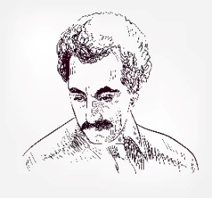
“I think in life you should work on yourself until the day you die.”

- Serena Williams, American professional tennis player


Quotes on Self-Reflection (Continued)
Quote | Paraphrase the Quote | Do you agree with this quote? Why or why not?
“The journey into self-love and self-acceptance must begin with self-examination… until you take the journey of self-reflection, it is almost impossible to grow or learn in life.”

-Iyanla Vanzant, American inspirational speaker, lawyer, and author
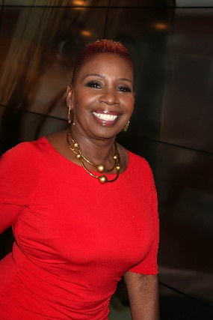

“Self-reflection is a humbling process. It’s essential to find out why you think, say, and do certain things—then better yourself.”

-Sonya Teclai,

Singer, songwriter, author

Quotes on Self-Reflection (Continued)
Quote | Paraphrase the Quote | Do you agree with this quote? Why or why not?
“The unexamined life is not worth living.”
- Socrates, classical Greek philosopher credited as one of the founders of Western philosophy

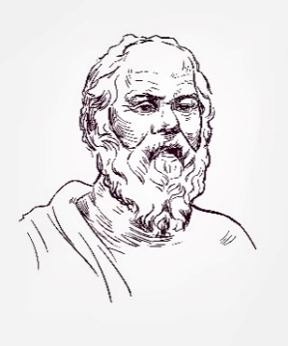
“These years in silence and reflection made me stronger and reminded me that acceptance has to come from within and that this kind of truth gives me the power to conquer emotions I didn’t even know existed.”

– Ricky Martin, Puerto Rican singer, actor, Grammy Award winner
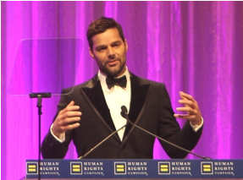

Stamp Your Learning for Quotes on Self-Reflection
Directions: Answer the following questions in complete sentences.

- Which quote resonates with you most and why?

________________________________________________________________________________________________________________________________________________________________________________________________________________________________________________________________________________________________________________________________________________________________________
__________________________________________________________________________________________

- Which of the quotes would you share with others? Why?

________________________________________________________________________________________________________________________________________________________________________________________________________________________________________________________________________________________________________________________________________________________________________
__________________________________________________________________________________________

- Explain a recent time you used self-reflection and how it supported you. If you haven’t self-reflected recently, think of a time when self-reflection would have been helpful.

________________________________________________________________________________________________________________________________________________________________________________________________________________________________________________________________________________________________________________________________________________________________________
__________________________________________________________________________________________

