Name: __________________________ Date: __________________
Quotes About Courage
Objective: Explore some perspectives on courage and determine whether they align with your own views.

Directions: Read and paraphrase the quotes below. Then, decide to what extent you agree with the quote.
Quote | Paraphrase the Quote | Do you agree with this quote? Why or why not?
“Courage is not the absence of fear but rather the assessment that something else is more important than fear.”
— Franklin D. Roosevelt, 32nd President of the United States from 1933-1945
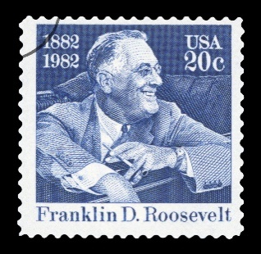
“Courage doesn't always roar. Sometimes courage is the little voice at the end of the day that says I'll try again tomorrow.”
— Mary Anne Radmacher, American writer and artist
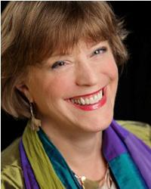
Quotes about Courage (Continued)
Quote | Paraphrase the Quote | Do you agree with this quote? Why or why not?
"Courage is the most important of all the virtues because without courage, you can't practice any other virtue consistently."
― Maya Angelou, American author, poet, memoirist, actor, lecturer, and civil rights activist
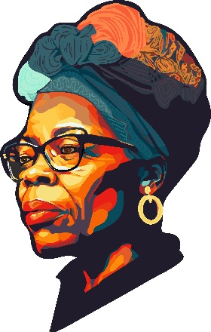

“Scared is what you’re feeling. Brave is what you’re doing.”
— Emma Donoghue, Irish historical novelist
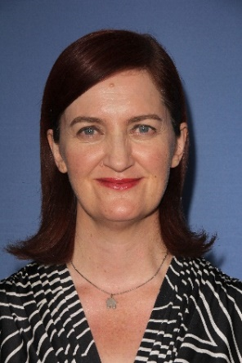

Stamp Your Learning for Quotes about Courage
- Consider the quote by Maya Angelou quote, "Courage is the most important of all the virtues because without courage, you can't practice any other virtue consistently." You may have studied the following virtues: integrity, responsibility, compassion, and/or respect. Choose one of these and explain how it supports or refutes Angelou’s quote.
- Integrity: Having a strong dedication to a code of moral values and principles.
- Responsibility: Taking ownership of and accountability for your actions and words.
- Compassion: Recognizing the suffering of others and feeling motivated to alleviate that suffering in some way.
- Respect: Demonstrating high regard for someone or something; treat yourself and others in a way that shows concern and support.
________________________________________________________________________________________________________________________________________________________________________________________________________________________________________________________________________________________________________________________________________________________________________
__________________________________________________________________________________________

- In “Lesson A: What is Courage?”, we defined courage as identifying a risk, considering alternative actions that might be taken, and deciding to act in a manner that incurs risk (intentionality)—with the goal of obtaining a greater good for the self or others (a ‘noble’ goal).

Consider Emma Donoghue’s quote, “scared is what you’re feeling. Brave is what you’re doing.” How does this fit with the definition of courage above? Address at least one of the components of the definition – risk, intentionality, and a noble goal.
________________________________________________________________________________________________________________________________________________________________________________________________________________________________________________________________________________________________________________________________________________________________________
__________________________________________________________________________________________

“Guest Profile.” Mary Anne Radmacher. Accessed November 21, 2024. https://www.thedrpatshow.com/guest/mary-anne-radmacher,1524.html.

