Name: __________________________ Date: __________________
Homeroom: _____________________
The Science of Peer Pressure

Directions: Read the following diagram and answer the questions that follow.
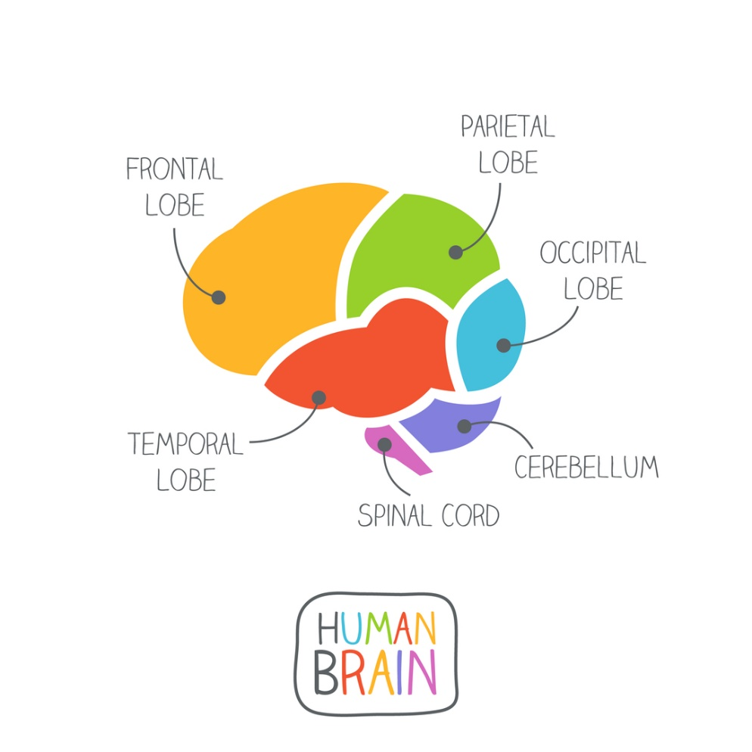
When you’re with your friends, you’re more likely to make choices you wouldn’t make on your own.
One of the reasons is because of the way your brain is wired. According to research, your brain is designed to learn through imitation, or copying the behaviors of others. As you get older, you imitate your parents less and your peers more.
There are two important facts about your brain to help understand how it makes decisions.
Let’s look at the diagram of the brain, to the right. First, find the frontal lobe. This is where your prefrontal cortex lives. This part of your brain is responsible for helping you decide whether something is right or wrong based on the consequences. It’s also the last part of the brain to develop! Research show it doesn’t fully develop until you’re about 25.
The slow development of the prefrontal cortex helps explain why you may find yourself doing things with your friends that you wouldn’t do on your own. Research shows that the more friends you’re surrounded by, the more likely you are to go along with the crowd, instead of making your own decision.

The Science of Peer Pressure (Continued)
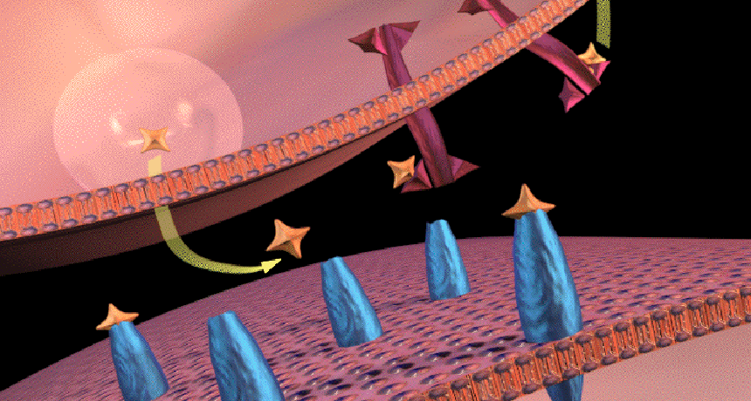
This picture shows dopamine (orange stars) leaving one brain cell and attaching to another cell.
Second, everyone’s brain has a chemical called dopamine (dope-uh-meen) in the reward center. This chemical sends signals throughout your brain, making you feel happy after receiving a reward. (See picture below.)
During adolescence, the amount of dopamine travelling through your brain is greater than any other time in life.
This means when you receive a reward (such as acceptance from your friends for going along with a choice), your brain will react more strongly than an adult or child. Because your friends are such an important part of your life, you’ll pay less attention to the downsides of a poor choice (like missing content if you skip class) and feel a greater rush from the reward (feeling like part of the group) and want to repeat that feeling as often as possible.
Understanding the science behind your brain’s functions can help you resist peer pressure and learn to think on your own. Before deciding, take extra time to consider both the negative and positive consequences of a choice. Take a moment to put aside the strong feeling of an emotional reward (like feeling accepted or impressing others) and consider whether the decision goes along with your personal values and beliefs.
Taking a few extra moments to think things through will help you make the right decision for yourself and avoid any feelings of regret later.

The Science of Peer Pressure Reflection Questions
Directions: In your neatest handwriting and in complete sentences, answer the following questions:
- Which part of the brain is the last to develop?
- dopamine
- frontal lob
- prefrontal cortex

- How does dopamine impact decision making?

____________________________________________________________________________________________________________________________________________________________________________________________________________________________________________________________________________________________________________________________________________________________

- Based on the article, explain why you are more likely to go along with a decision your friends are making than on your own.

____________________________________________________________________________________________________________________________________________________________________________________________________________________________________________________________________________________________________________________________________________________________

Stamp Your Learning for The Science of Peer Pressure

Directions: Answer the following questions in complete sentences.

- How will your understanding of the brain’s functions impact your decision making in the future?
____________________________________________________________________________________________________________________________________________________________________________________________________________________________________________________________________________________________________________________________________________________________

- Describe a situation you recently experienced when acceptance from your friends prevented you from thinking on your own. How would you change your decision, if you had the chance?

____________________________________________________________________________________________________________________________________________________________________________________________________________________________________________________________________________________________________________________________________________________________

- Instead of immediately responding to an emotional reward from your friends, what action step can you take to ensure you’re thinking on your own?

____________________________________________________________________________________________________________________________________________________________________________________________________________________________________________________________________________________________________________________________________________________________

peers: people your age or close to your age
Heads up by Scholastic http://headsup.scholastic.com/sites/default/files/dayinlife.pdf Accessed and edited on 1/14/2020
The Science of Decision Making and Peer Pressure by Scholastic http://headsup.scholastic.com/students/the-science-of-decision-making-and-peer-pressure Accessed and edited on 1/14/2020
Explainer: What is dopamine? by Science News for Students https://www.sciencenewsforstudents.org/article/explainer-what-dopamine Accessed on 1/14/2020
adolescence: period of life (between ages 10-19) when a child develops into an adult

