Name: __________________________ Date: __________________
Homeroom: _____________________
Writing Effective SMART Goals

Directions: Review the following SMART Goals graphic and answer the question that follows.

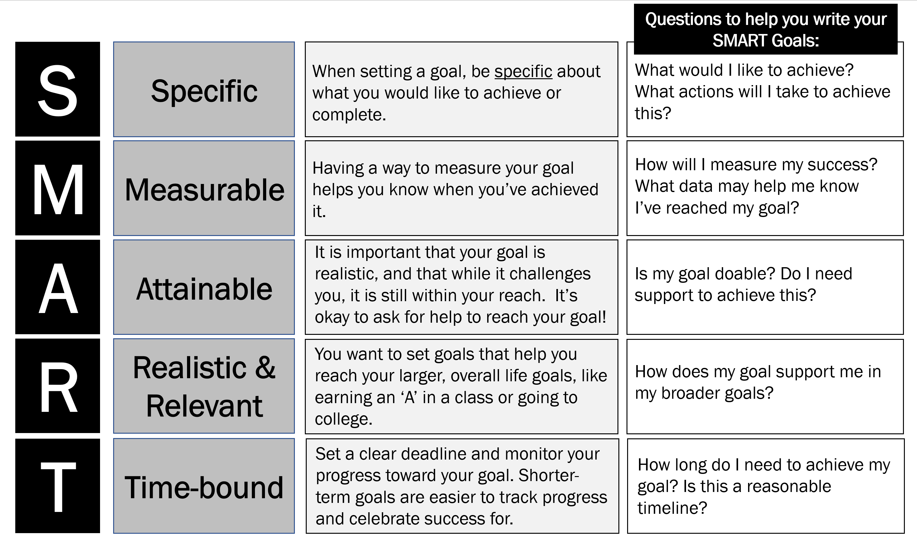

Stop & Jot: What questions do you have about SMART goals after reviewing the image above?

______________________________________________________________________________________________________________________________________________________________________________________________________________________________________________________________________________

Writing Effective SMART Goals Reflection Questions
Directions: Read the following goals and identify which components of a SMART Goal they meet. Explain your reasoning for any component the goals do not meet. The first row has been done as an example.
Goal | Is this goal… | Explain your reasoning for each box you did not check.
Practice for basketball drills every day for 2 hours to be better at making free throws. |  | EXAMPLE: This goal is not attainable because 2 hours of practice every day is an unreasonable amount of time.  This goal is not time-bound because there is no end point. It just says “every day.”
Eat a piece of fruit at least once a day this month. | - Specific?  - Measurable?  - Attainable?  - Realistic & Relevant?  - Time-bound?
Get good grades in all of my classes for the first 3 weeks of school. | - Specific?  - Measurable?  - Attainable?  - Realistic & Relevant?  - Time-bound?
Have excellent behavior by not being sent out of math class this year. | - Specific?  - Measurable?  - Attainable?  - Realistic & Relevant?  - Time-bound?
Get a perfect score on all of my science quizzes and tests for the first semester. | - Specific?  - Measurable?  - Attainable?  - Realistic & Relevant?  - Time-bound?
Show up to school every day. | - Specific?  - Measurable?  - Attainable?  - Realistic & Relevant?  - Time-bound?
Stamp Your Learning for Writing Effective SMART Goals
- Read the following goal and re-write it to be more measurable.

I will ask my sister to practice my Spanish flashcards with me so I can get better at recalling vocabulary.

_______________________________________________________________________________________
_______________________________________________________________________________________
_______________________________________________________________________________________

- Read the following goal and re-write it to be more specific.

I will be nicer to my classmates.

_______________________________________________________________________________________
_______________________________________________________________________________________
_______________________________________________________________________________________

- Read the following goal and re-write it to be more time-bound.

To get feedback on my English essay, I will attend English tutoring every Monday and Wednesday.

_______________________________________________________________________________________
_______________________________________________________________________________________
_______________________________________________________________________________________

- Write a SMART goal for yourself. Your goal could be academic or personal.

_______________________________________________________________________________________
_______________________________________________________________________________________
______________________________________________________________________________________________________________________________________________________________________________

