Name: __________________________ Date: __________________
Writing Effective SMART Goals

Objective: Analyze and write goals according to the SMART framework.

Directions: Review the following SMART Goals graphic and answer the question that follows.
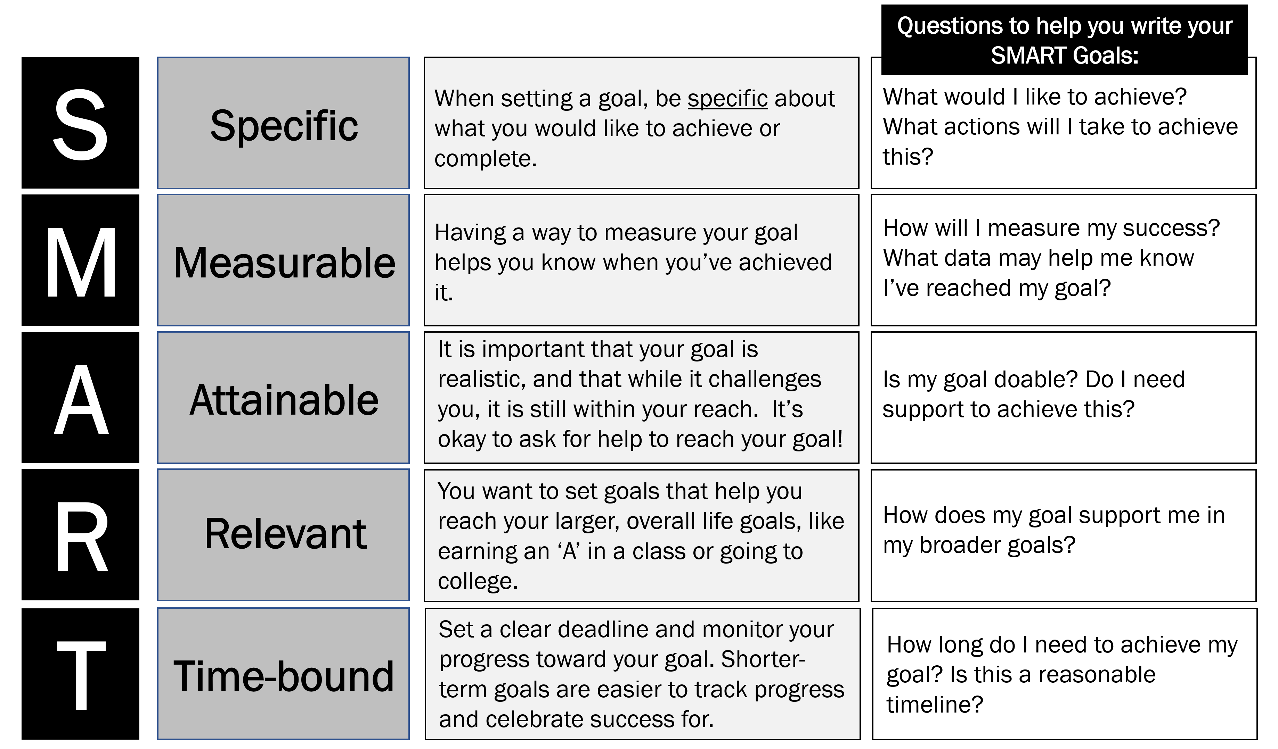
Stop & Jot: Using the image above, which component of a SMART goal do you think will be the most challenging if you were writing a SMART goal for yourself? Explain why.
__________________________________________________________________________________________________________________________________________________________________________________________________________________________________________________________________________________________________________________________________________________________________________________________________________________________________________________________________

Writing Effective SMART Goals Reflection Questions
Directions: Read the following goals and identify which components of a SMART Goal they meet. Explain your reasoning for any component the goals do not meet. The first row has been done as an example.
Goal | Is this goal… | Explain your reasoning for each box you did not check.
Practice for basketball drills every day for 2 hours to be better at making free throws. | 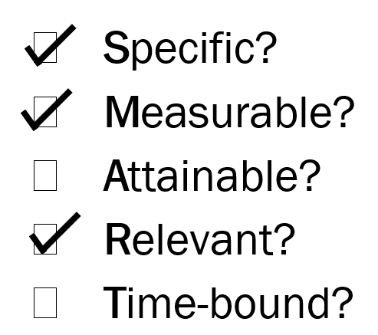 | EXAMPLE: This goal is not attainable because 2 hours of practice every day is an unreasonable amount of time.  This goal is not time-bound because there is no end point. It just says “every day.”
Eat a piece of fruit at least once a day this month. | - Specific?  - Measurable?  - Attainable?  - Relevant?  - Time-bound?
Get good grades in all of my classes for the first 3 weeks of school. | - Specific?  - Measurable?  - Attainable?  - Relevant?  - Time-bound?

Chart continues on p. 3.

Goal | Is this goal… | Explain your reasoning for each box you did not check.
Maintain excellent participation by not being sent out of math class this year. | - Specific?  - Measurable?  - Attainable?  - Relevant?  - Time-bound?
Get a perfect score on all of my science quizzes and tests for the first semester. | - Specific?  - Measurable?  - Attainable?  - Relevant?  - Time-bound?
Show up to school every day. | - Specific?  - Measurable?  - Attainable?  - Relevant?  - Time-bound?

Stamp Your Learning for Writing Effective SMART Goals
- Read the following goal and re-write it to be more measurable.

I will ask my sister to practice my Spanish flashcards with me so I can get better at recalling vocabulary.
______________________________________________________________________________________________________________________________________________________________________________________________________________________________________________________________________________
- Read the following goal and re-write it to be more specific.

I will be nicer to my classmates.
______________________________________________________________________________________________________________________________________________________________________________________________________________________________________________________________________________
- Read the following goal and re-write it to be more time-bound.

To get feedback on my English essay, I will attend English tutoring every Monday and Wednesday.
______________________________________________________________________________________________________________________________________________________________________________________________________________________________________________________________________________
- Write a SMART goal for yourself. Your goal could be academic, procedural, or social. If you completed Lesson A, return to the academic and behavioral goals you wrote at the end. Re-write one of these to be in the SMART form.

__________________________________________________________________________________________________________________________________________________________________________________________________________________________________________________________________________________________________________________________________________________________________________________________________________________________________________________________________

