Name: __________________________ Date: __________________
What is Respect?
Objective: To define respect and identify what respect looks like in different scenarios.

- How do you define respect?
________________________________________________________________________________________________________________________________________________________________________________________________________________________________________________________________________________________________________________________________________________________________________
- Respect can mean many different things to many different people, but a common definition is:
Demonstrating high regard for someone or something; treating yourself and others in a way that shows concern and support.
How does this definition compare to yours?
________________________________________________________________________________________________________________________________________________________________________________________________________________________________________________________________________________________________________________________________________________________________________

What is Respect? (Cont’d)
- Below, jot some ideas about how you might show respect in each specific situation. Try to be as specific as possible.
Respecting a specific person (perhaps a family member, a peer, a teacher) | Showing respect to a school community | Respecting a physical space (perhaps your school building or home)
 | 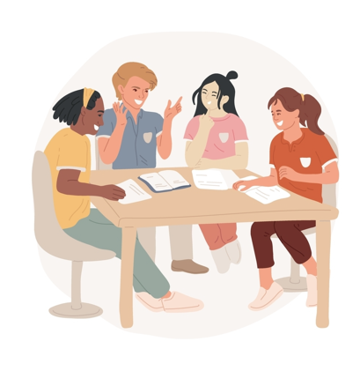 | 
- With direction from your teacher, dean, or other school leader, share your ideas with a partner or group. Add at least one idea from a peer in each category.

What is Respect? (Cont’d)
From the article: The neuroscience of respect: insights from cross-cultural perspectives
As respect motivates people to validate and acknowledge the feelings of others, it has a crucial role in human relationships, one facet of which is empathy, the ability to feel and comprehend the experiences of others (Decety and Jackson, 2004). The association between respect and empathy is likely bidirectional; when individuals respect others, they are more likely to feel empathy for them, and when they feel respected, they may express their emotions more openly and honestly and elicit greater empathy. Feelings of mutual respect, therefore, can lead to better emotional connection and understanding between individuals (Li and Fischer, 2007).
bidirectional: works in two (usually opposite) directions
elicit: bring out or draw forth from something

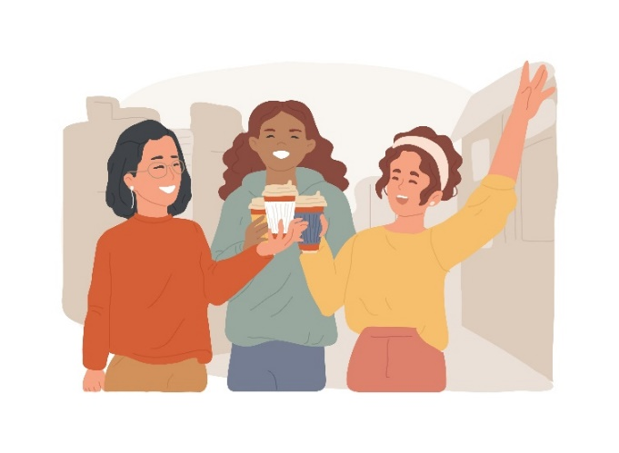
- Consider the last statement in this reading – “Feelings of mutual respect, therefore, can lead to better emotional connection and understanding between individuals.”

  - Explain a situation in which this is true. You can think about a personal experience or a situation from history, current events, etc.
________________________________________________________________________________________________________________________________________________________________________________________________________________________________________________________________________________________________________________________________________________________________________
  - Think about a situation where mutual respect is lacking. How did/does it show a corresponding lack of empathy as well?
________________________________________________________________________________________________________________________________________________________________________________________________________________________________________________________________________________________________________________________________________________________________________

Stamp Your Learning for What is Respect?
- Here's 'The Golden Rule' that we teach young children— treat others as you want to be treated.

  - We might think of it as simplistic, but how does it reflect the definition of respect?
________________________________________________________________________________________________________________________________________________________________________________________________________________________________________________________________________________________________________________________________________________________________________
  - How does the Golden Rule support the connection between respect and empathy? Why might adults do well to remember this teaching from their childhood?
________________________________________________________________________________________________________________________________________________________________________________________________________________________________________________________________________________________________________________________________________________________________________

Khalaila, Rabia, et al. “The neuroscience of respect: insights from cross-cultural perspectives.” Frontiers in Psychology December 2023. 10.3389/fpsyg.2023.1259474

