Name: __________________________ Date: __________________
What is Compassion?
Objective: To define compassion and evaluate an example of compassion from Dwayne ‘The Rock’ Johnson.
- Take a moment to think about the term compassion. What does compassion mean to you? Where might compassion show up in our school community? At home? In your feelings toward yourself? Jot some ideas below:
Notes
- There is some debate on how to precisely define compassion in the academic community, but compassion is generally accepted to mean recognizing the suffering of others and feeling motivated to alleviate that suffering in some way.
How does this definition compare with how you described compassion in question 1?
__________________________________________________________________________________________________________________________________________________________________________________________________________________________________________________________________________________________________________________________________________________________________________________________________________________________________________________________________

What is Compassion Reflection Questions

- Read the following bio about Dwayne “The Rock” Johnson:

Dwayne “The Rock” Johnson
In 2019, Dwayne “The Rock” Johnson was awarded the Generation Award from MTV. The Generation Award was created to recognize those who were teenagers in the 1980s and 1990s and were part of the “MTV Generation,” or those whose music and fashion sense were instrumentally impacted by watching MTV.
The Rock got his start as a pro-wrestler with World Wrestling Federation (WWF, now known as WWE) in 1996. He started being hired for small acting gigs around 1999, but his acting career took off in the 2010s when he booked much more visible and larger roles in movies like Fast Five. He has since become one of the highest paid actors in Hollywood.
Read the transcript of Dwayne Johnson’s acceptance speech for the MTV Generation Award (p. 3). Jot down any words, phrases, or sentences that highlight Johnson’s understanding of compassion.

- In his speech, The Rock says there is a quote he heard when he was fifteen years old that has stuck with him:
It’s nice to be important, but it’s more important to be nice.
How does this quote relate to your understanding of compassion?
__________________________________________________________________________________________________________________________________________________________________________________________________________________________________________________________________________________________________________________________________________________________________________________________________________________________________________________________________

What is Compassion Reflection Questions (Continued)
The Rock’s MTV Generation Award Acceptance Speech Transcript
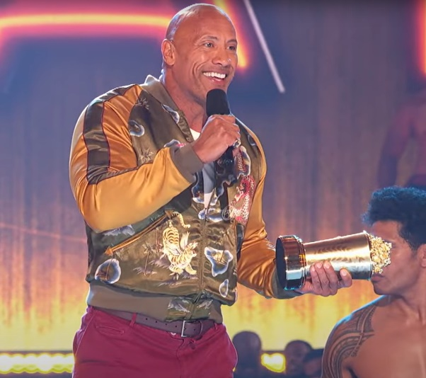
The most powerful thing that we can be is ourselves. […] We’re always that little kid, and we’re still that little kid, right, just aspiring to be something better, aspiring to be important.
So, when I first got to Hollywood…Hollywood, they didn’t know what the hell to do with me. I mean, I was this half Black, half Samoan, 6’4”, 275-pound pro-wrestler.
You know, I was told at that time, well, you gotta be a certain way. You gotta drop some weight. You gotta be somebody different. You gotta stop working out. Stop doing the things that I love. You gotta stop calling yourself “The Rock.” What? […]
You know, and for years, I actually – I bought into it, because you think, oh that’s what I’m supposed to do. And I was miserable doing that, so I made a choice. And the choice was, I wasn’t gonna conform to Hollywood. Hollywood was gonna conform to me.
So Hollywood conformed to me, and here I am with all of you, getting the Generation Award! What you saw up here tonight [Samoan dancers], I mean, that’s who I am. I’m proudly half Black and half Samoan, and I wanted to bring those cultures here, up here for the world to see.
So, yes it’s important that you are your most authentic self. I’m a walking example of that. But here’s the thing that I want to share with you guys. That’s not enough. Because there’s another side to being your authentic self, your true self, and that’s the side that the magic is on.
That’s the side that’s gold. And while, yes, it’s important to be yourself, you gotta recognize the joy and the responsibility of bringing everybody with you. We bring everybody with us, and you do that by being kind, by being compassionate, by being inclusive, and straight up, just being good to people, because that matters. And if you can hit that place, that’s when you become powerful. That’s when you can have real global influence in a positive way.
So, that said, I leave you with this. When I was 15 years old, I heard a quote and I will never forget it, and I bring it with me everywhere I go, and it’s ingrained in my DNA. The quote is this, “It’s nice to be important, but it’s more important to be nice.”
With that, I love you, I thank you, […] I will see you all down the road. Thank you very much!

conform: to be obedient; to comply with or follow rules set by someone else

What is Compassion Reflection Questions (Continued)

- Read the article below to understand some background about an actor’s strike, which Dwayne Johnson became involved in.
The Actors’ Strike – Background
SAG-AFTRA, sometimes called the Screen Actors Guild, is the labor union for “actors, announcers, broadcast journalists, dancers, DJs, news writers, news directors, program hosts, puppeteers, recording artists, singers, stunt performers, voiceover artists and other media professionals.” A labor union is an organization formed by workers who can use their voices together to bargain for specific desires in the workplace such as fair wages, health care, and safety.
You may have heard of SAG-AFTRA during its 2023 strike, which caused a large disruption to the entertainment community. From July to November of 2023, the union went on strike after their bargaining committee could not reach an agreement with major movie and television producers about the need for greater income and for protections against using artificial intelligence to create likenesses of the actors, among other demands. New movies and episodes of television shows were put on pause while their actors stopped working during the strike.
When we think about actors, we often think about the most famous, those who command huge salaries, and we might feel like they certainly don’t need to strike for more money. And while some of those big-name actors like Jennifer Lawrence, Quinta Brunson, and Lupita Nyong’o joined the strike, many of the strikers are actors who are not household names, who do not earn large salaries, and who often hold other jobs to pay their bills. When these actors strike, they are not working and are not paid. For them, this financial loss can threaten their ability to pay for housing, food, and other necessities.
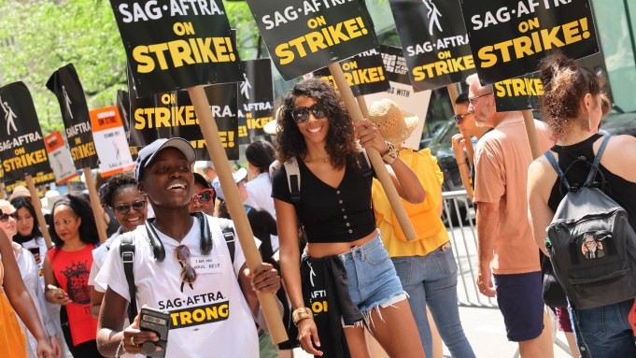
strike: refusing to work as a form of protest and a way to make employers listen to and accept your demands

Lupita Nyong’o striking with other actors in New York
Why might someone feel compassion for the striking actors?
Notes
What is Compassion Reflection Questions (Continued)

- Continue reading to discover Johnson’s role in the actor’s strike.
The Actors’ Strike – The Rock Responds
To aid actors in financial crisis, the union’s foundation gives emergency assistance grants. During the strike, Dwayne Johnson donated over one million dollars to the cause; the exact amount was undisclosed, but in an interview with Variety, the president of the SAG-AFTRA Foundation, Courtney B. Vance, and the Executive Director, Cyd Wilson, reported that it was the largest donation the foundation has ever received from a single person, and it had the potential to financially support between 7,000 and 10,000 actors.
Vance said, “[The Foundation’s] mandate and mission is to be able to help members in times of need and crisis financially—their medical bills, their rents, their mortgages, and their food. And that’s where we find ourselves again. [Our members are] on the picket lines, but they still have to be able to pay for things.”
Wilson reported, “The general public might think that all actors make millions of dollars, and there are some that do but that’s a very small percentage. The majority of our actors have second and third jobs – they’re waiting tables, catering, driving Uber. It may not seem like a lot, but when you miss $1,000 to $3,000 a month that you would normally get, that can be a financial ruin.”
When Wilson and Vance were asked about their reaction to Johnson’s donation, Wilson said, “What is amazing is that that one check is going to help thousands of actors keep food on their table, and keep their kids safe, and keep their cars running. And it’s not lost on me that he’s very humble about this.” Vance replied, “I want to thank Dwayne for his tremendous generosity, compassion, and initiative to step up in this significant and meaningful way for our community. On behalf of the thousands who will be helped by his historic donation, thank you, thank you, thank you.”
grants: money loaned to you that you do not have to pay back
mandate: authority given to a group to act
picket lines: gatherings of groups of people on strike, usually outside their place of business
humble: modest; not looking for recognition
- Remember that compassion means recognizing the suffering of others and feeling motivated to alleviate that suffering in some way.
How is Johnson’s donation an example of compassion? Use the definition of compassion in your response.
__________________________________________________________________________________________________________________________________________________________________________________________________________________________________________________________________________________________________________________________________________________________________________________________________________________________________________________________________
Stamp Your Learning for What is Compassion

- In Johnson’s acceptance speech, he said the following:
And while, yes, it’s important to be yourself, you gotta recognize the joy and the responsibility of bringing everybody with you. We bring everybody with us, and you do that by being kind, by being compassionate, by being inclusive, and straight up just being good to people, because that matters. And if you can hit that place, that’s when you become powerful. That’s when you can have real global influence in a positive way.
Why does Johnson believe that compassion is important? Given what you learned about his donation, do you feel he’s living up to his words?
____________________________________________________________________________________________________________________________________________________________________________________________________________________________________________________________________________________________________________________________________________________________________________________________________________________________________________________________________________________________________________________________________________________________

https://www.sagaftra.org/about
https://variety.com/2023/film/news/dwayne-johnson-donation-sag-aftra-foundation-strike-relief-fund-1235678671/

