Name: __________________________ Date: __________________
Objective: Explain the purpose of self-reflection and apply a self-reflection framework to some scenarios.

Benefits of Self-Reflection
Fundamentals of Self-Reflection

Do you ever stop and think to yourself: Why did I do that? How might I have done that differently? What might happen if I said…? If you answered yes, then you have done some self-reflection. Self-reflection is when you take time to think about, or evaluate, your choices, thoughts, goals, relationships, or other parts of your life that are important to you.
Some people choose to be self-reflective, making a habit of writing in a journal or designating a time during their day to reflect silently. Sometimes, people are asked to reflect on their actions, feelings, or academic progress by an advisor, dean, counselor, or teacher.
- On a scale of 0 to 5, how frequently do you engage in self-reflection?
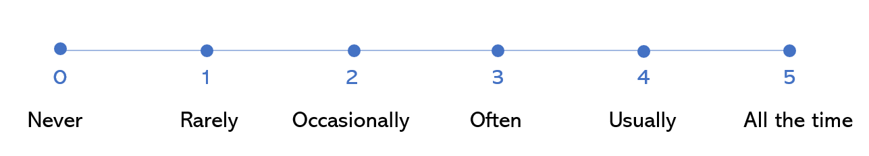
Explain your choice:
_______________________________________________________________________________________________________________________________________________________________________________________________________________________________________________________________________________________

- As you read the following text, annotate ways that self-reflection supports personal growth:
Self-Reflection Supports Personal Growth
Self-Reflection in the Moment: Many times, we just react to situations without taking a moment to think about what we’re feeling. When we’re frustrated or upset, emotions can cloud our judgment and prevent us from responding productively or thoughtfully. However, when we take a moment to pause and reflect on what we are feeling, our role in the situation, and how to move forward, we are more likely to handle the situation in a mature and helpful way. Part of growing into our adult selves is remembering to reflect on our actions and emotions—event for just a brief moment—while a situation is unfolding.
Self-Reflection for the Future: Self-reflection is a smart way to help you prepare for the future. For example, let’s say you have been finding it difficult to work with a certain peer in school or a colleague at work. Making time to journal about the situation can help you figure out how to best handle it. Reflecting about what feelings arise, your role in the potential conflicts, or a few ways you might move forward in a productive, positive way is a technique that can set you up for success in future interactions. The more you do this, the more you can equip yourself to respond in a helpful, effective, and healthy way in the future!
According to the paragraphs above, how does self-reflection support personal growth?

- The following text describes the “What? So what? Now what? Cycle,” a series of questions that can help you reflect more effectively. Read the text, then move to the activity on pp. 3-5.
The “What? So what? Now what?” Cycle
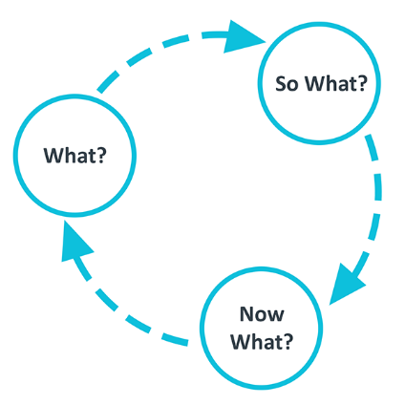
This model is one of the simplest frameworks for reflection. In practice, you should ask yourself three questions after something has happened that you want to learn from:
- “What?” helps you describe the situation. “What” helps you identify the facts and your feelings about the situation.
- “So What?” allows you to think more deeply about the 'What.’ Asking “so what’ helps you consider why you did what you did.
- “Now what?” allows you to create an action plan for the future based on the previous questions.
Using this simple framework guides us to learn from our experiences. And remember to reflect on both your mistakes and your successes! While we are often told that we learn from our mistakes, it is equally helpful to reflect on our successes, so we can continue to build on them.
- For each step of the “What? So what? Now what?” Cycle, review the supporting questions and the examples:

The What? describe the experience of the situation. Helpful questions to ask yourself:
What…
- was I trying to achieve in the situation?
- was my role in the situation? What role did others play? (if applicable)
- were the consequences for me? For others?

Example #1: Sharing personal information  I sit beside my classmate, David, in two different classes. Recently, he told me that his sister was getting bullied on social media. I told a friend because I was concerned, and my friend told a teacher, who called David’s family. David confronted me about sharing his private information without him giving permission. Now he won’t speak to me, even during classwork. | Example #2: Getting assistance on an assignment  I recently submitted an essay in Spanish that I thought I would earn a good grade on. I expected a 90 or higher based on the grades I’d gotten previously. I finished the assignment the night before, so I didn’t have time to go to Spanish office hours for help. I used Google Translate for several parts of the assignment even though we were told not to use any translation assistance. My intention was to use it just to check my own translations, but my teacher recognized some of the translation as being from an automated translator. I earned an F on the assignment.

- Select a situation that would benefit from self-reflection. Use the questions above to describe the What? for this situation.

______________________________________________________________________________________________________________________________________________________________________________________________________________________________________________________________________________________________________________________________________________________________________________________________________________________________________________________________________________________________________________________________________________________________________________________________________________________________________________________

So what? reflects on the implications of the situation. Helpful questions to ask yourself (and, at times, to ask others so you benefit from their knowledge and experience) to help you think through implications:

So what…
- was I thinking during the situation?
- did I base my actions on?
- could I have done differently to get a more desirable outcome?
- does this teach me about myself?
- is my new understanding of the situation?

Example #1: Sharing personal information  Given David’s response, it’s clear he’s frustrated that this information was told to a peer and teacher without him knowing. He thought he was confiding in me privately. To be completely honest with myself, I thought it was a crazy bit of gossip to share with my friend, but he was concerned about David’s sister’s safety. I should have asked David if his parents knew about the situation already. I recognize now that I treated someone’s painful experience as something interesting to tell a friend. I also now don’t have a partner in two classes since he’s not speaking to me. | Example #2: Getting assistance on an assignment  I didn’t think it was a big deal to use Google Translate to check my translations because I had written my assignment using my own understanding of the Spanish language. I did change some of my sentences based on the translator though, so I think that was cheating. I realize now I should have started on this assignment earlier so I could have used resources that were allowed instead of relying on Google Translate, which was explicitly not allowed. I think this is often a pattern of mine—I wait too long to start an assignment and then realize I’m not fully prepared to actually complete the assignment, so I take some shortcuts.

- Continue thinking about the situation you selected in Q4a. Use the questions above to describe the So What? for this situation.

______________________________________________________________________________________________________________________________________________________________________________________________________________________________________________________________________________________________________________________________________________________________________________________________________________________________________________________________________________________________________________________________________________________________________________________________________________________________________________________

Now what? helps you develop an action plan based on your reflection. This might include what you need to do to rectify the situation you reflected on, or what you need to do to prevent the situation from happening again. (Of course, if you reflected on a situation that had a positive outcome, the Now What? helps you continue or maintain those positive outcomes in the future.)

Now what…
- do I need to do in the future to do better in a similar situation?
- might be the consequences of my new action(s)?
- do I need to do to ensure that I will follow my plan?

Example #1: Sharing personal information  First, I need to apologize to David. I’m going to ask if I can talk to him in the hallway after 3rd period tomorrow, and I’m going to ask him how I can make the situation better. I’m going to offer to ask our teachers to move us away from each other if he’d prefer a different partner.  In the future, I am going to ask myself a few questions before sharing someone else’s information – did they give me permission to share this? Is it already widely known? Would it hurt someone if I shared? If someone is being hurt, am I sharing this information to the right person so they can help, or am I sharing just because I want a good story? Based on those questions, I’ll make a better decision about what and with whom I share. | Example #2: Getting assistance on an assignment  I know this isn’t just an issue in Spanish for me. I always wait until the last minute to start an assignment. I need to do some backwards planning from when my assignments are due, consider when office hours and block time in my calendar for when I will work on my assignments.  I’ve tried a handwritten planner before, and I don’t like it much, so I’m going to use Google calendar. When I get long-term assignments like the Spanish essay, I will put it into my calendar. I will also put all office hour sessions for my classes into my calendar, and then I will block off time at least a week before office hours so I have a draft to bring if I need help.

- Use the So What? questions above to complete your reflection on the situation.

______________________________________________________________________________________________________________________________________________________________________________________________________________________________________________________________________________________________________________________________________________________________________________________________________________________________________________________________________________________________________________________________________________________________________________________________________________________________________________________

Stamp Your Learning for Benefits of Self-Reflection

Directions: Answer the following questions in complete sentences.

- How or when might you see this reflection cycle – What? So what? What now? – helping you?

________________________________________________________________________________________________________________________________________________________________________________________________________________________________________________________________________________________________________________________________________________________________________

- During the So what? reflection, it can be helpful to reflect with a trusted peer or adult. Who are some people you know who might be wise and supportive reflection partners?

_______________________________________________________________________________________________________________________________________________________________________________________________________________________________________________________________________________________

- It’s helpful to reflect both on situations that go well and situations in which you might do better.

If you reflected on a situation that went well in Q4, what’s one mistake you made that you should probably go back and reflect on? Or, if you reflected on a situation that did not go well in Q4, what successful situation might you reflect on?

______________________________________________________________________________________________________________________________________________________________________________________________________________________________________________________________________________

University of Edinburgh editors, “What? So what? Now what,” Reflection Toolkit, The University of Edinburgh, Accessed September 25, 2023, https://www.ed.ac.uk/reflection/reflectors-toolkit/reflecting-on-experience/what-so-what-now-what.

