**Name**: __________________________ **Date: __________________**

**Homeroom**: _____________________

**Benefits of Self-Reflection**

**Fundamentals of Self-Reflection**

Do you ever stop and think to yourself: *Why did I do that? How might I have done that differently? What might happen if I do/say…?* If you answered yes, then you have done some self-reflection! Self-reflection is when you take time to think about, or evaluate, your choices, thoughts, goals, relationships, or other parts of your life that are important to you.

When self-reflecting, you might silently reflect in your mind or write down your reflections somewhere. At home, having a journal makes reflection easy because You can make self-reflection more effective by having a designated space to reflect, like a journal, and a consistent time when you make space to reflect, like the end of every school day. In school, your Dean, advisor, or teacher may ask you to reflect on your choices or academic progress as well.

**Self-Reflection Supports Personal Growth**

Many times, we just react to situations without taking a moment to think about what we’re feeling. When you get frustrated or upset, emotions often cloud your judgment and prevent you from responding in a productive or healthy way. If you pause and take a moment to reflect on how you are feeling, your role in a conflict, and what you need moving forward, you are much more likely to be able to navigate a conversation with someone else in a way that makes both of you feel supported and honored.

While self-reflection in the moment can support you in navigating a challenging situation, you can also use self-reflection as a tool for current you to support future you! For example, let’s say you have been finding it difficult to resolve a conflict with a friend. Journaling your feelings and how you would like to make progress with them would allow you to consider why you’re having a difficult time resolving the conflict with them, what part you might play in those interactions, and how you would like to move forward in a productive, positive way. The more you do this, the more equipped you will be to respond in a helpful way in the future!

**Stop & Jot:** According to the paragraphs above, how does self-reflection support personal growth?

__________________________________________________________________________________________

__________________________________________________________________________________________

__________________________________________________________________________________________

**Self-Reflection Helps You Reach and Adjust Your Goals**

At this point in your life, you may be aware of how helpful it is to set goals. You might have goals like making the dance team, earning a 90 or higher in Social Studies, or earning enough money to buy a new game. Goals are important because they help you focus your actions, promote a sense of success and satisfaction, and support mental health. However, one often forgotten but incredibly important components of reaching a goal is self-reflection.

When you set a goal, you hopefully also set a time to reach your goal. By setting aside time to reflect on your progress, you give yourself the opportunity to celebrate what you’ve done so far and adjust if needed. For example, if your goal is to earn a 90 or higher in Social Studies for quarter 2, you might keep a tracker of your assignment grades for the course and set aside 10 minutes every week to consider if you are on track and what you need to do to get back on track, if needed.

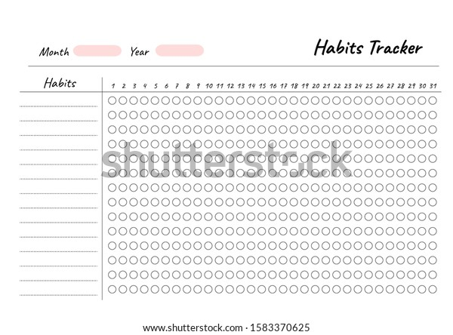

Self-reflection also helps you adjust your goal if you need to. Maybe Social Studies is turning out to be very challenging, and you need to adjust your goal score. This is okay and a normal process of setting and pursuing goals. You might decide your new goal is to earn an 82 or higher in Social Studies, but you wouldn’t be able to do this without reflecting on your progress throughout.

**Stop & Jot:** Based on the passage, what’s one way self-reflection can help you reach or adjust your goals?

__________________________________________________________________________________________

__________________________________________________________________________________________

__________________________________________________________________________________________

**Self-Reflection Supports Learning**

In school, we learn many things in one day. Cognitive scientists, scientists who study learning and how the brain works, have found that we have two primary areas of memory in our brain – we have our working memory and our long-term memory. Our working memory is the space where we can problem solve, plan, reason, and comprehend various tasks, but we can only keep information there for a short time, and it is limited in its space. Long-term memory is the part of our brain where we can store any amount of knowledge forever, but we cannot use that space to problem solve.

**Stop & Jot:** According to the paragraph above, what are the differences between working memory and long-term memory?

__________________________________________________________________________________________

__________________________________________________________________________________________

__________________________________________________________________________________________

The goal in learning is to move information from our working memory to our long-term memory. This can be done with self-reflection. If you pause after learning new information or receiving feedback on a paper and reflect on what you’ve learned or gained from that process, you are more likely to move that into your long-term memory to use forever.

For example, when you get your math quiz back, you might turn to your journal and jot down a few mistakes you made and solutions you want to remember. This will help you lock in your learning, move that information to long-term memory, and better prepare for your next assessment.

**Stop & Jot:** How does self-reflection support learning, according to the passage?

__________________________________________________________________________________________

__________________________________________________________________________________________

__________________________________________________________________________________________

***Benefits of Self-Reflection: Trackers***

**Tracker Example #1:** Grades Tracker

This student has listed their goal grades for their five core classes over the course of 5 weeks.

|  |  |  |  |  |  |  |
| --- | --- | --- | --- | --- | --- | --- |
|  | | **Grades** | | | | |
| **Subject** | **GOAL** | **Week 1** | **Week 2** | **Week 3** | **Week 4** | **Week 5** |
| **Math** | ≥ 85% | *79%* | *81%* |  |  |  |
| **Science** | ≥ 90% | *84%* | *84%* |  |  |  |
| **English** | ≥ 95% | *89%* | *90%* |  |  |  |
| **History** | ≥ 90% | *94%* | *93%* |  |  |  |

**Tracker Example #2:** Screen Time Tracker

This student set a goal of limiting their screen time to less than 1.5 hours on weekdays.

|  |  |  |  |  |  |  |
| --- | --- | --- | --- | --- | --- | --- |
| **Week** | **Day** | **Monday** | **Tuesday** | **Wednesday** | **Thursday** | **Friday** |
| 1 | Screen Time |  |  |  |  |  |
| Goal Met? | Yes / No | Yes / No | Yes / No | Yes / No | Yes / No |
|  | | | | | | |
| 2 | Screen Time |  |  |  |  |  |
| Goal Met? | Yes / No | Yes / No | Yes / No | Yes / No | Yes / No |

Choose one of the trackers to reflect on. How does this tracker help the student reflect on their progress?

________________________________________________________________________________________

________________________________________________________________________________________

________________________________________________________________________________________

**Stamp Your Learning for *Benefits of Self-Reflection* (cont’d)**

1. What is a goal you’d like to meet in the next few weeks? This could be an academic goal, a goal related to something at home, or a goal related to extracurriculars.

____________________________________________________________________________________

____________________________________________________________________________________

____________________________________________________________________________________

1. In the space below, create a tracker to help you reflect on your progress toward the goal you wrote in question 2. Use the trackers on pg. 4 to help inspire you.
2. How will the tracker you created above help you reflect on your progress toward this goal?

____________________________________________________________________________________

____________________________________________________________________________________

____________________________________________________________________________________