Name: __________________________ Date: __________________
Homeroom: _____________________
Peer Pressure Vocabulary

Directions: Read the following definitions and write a sentence using each vocabulary word.
Vocabulary: peer pressure, spoken pressure, unspoken pressure
Phrase | Definition | Situations | Image
peer pressure  noun | a situation involving a peer asking or pushing someone to do something | - The student gave in to peer pressure and skipped class.  - _____________________________________________________________________  _____________________________________________________________________ | 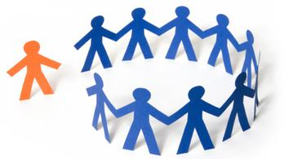
spoken pressure  verb | a situation involving words to ask or push someone to do something | - The captain of the basketball team used spoken pressure when they called a teammate a “loser” if they didn’t attend a party.  - _____________________________________________________________________  _____________________________________________________________________ | 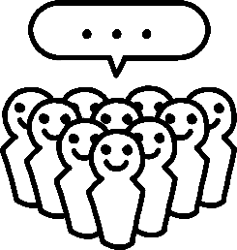
unspoken pressure  verb | a situation involving facial expressions or gestures to ask or push someone to do something | - Your best friend used unspoken pressure as she rolled her eyes when you said you needed to take notes instead of walking out of class.  - _____________________________________________________________________  _____________________________________________________________________ | 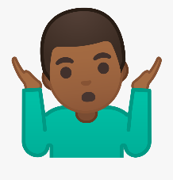

Peer Pressure Vocabulary (Continued)
Vocabulary: rejection, reasoning, self-awareness, refusal skills
Word | Definition | Situations | Image
rejection  noun | a threat to leave out another person if they do not do what they are asked | - The student feared rejection if they did not share an inappropriate picture on social media.  - _____________________________________________________________________  _____________________________________________________________________ | 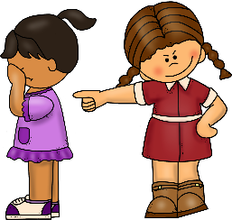
reason  verb | using statements to convince another person to do something | - I used reason when I asked my friend to help me study.  - _____________________________________________________________________  _____________________________________________________________________
self-awareness  verb | to have knowledge and understanding of your feelings and beliefs | - I can build self-awareness by reflecting on my choices and feelings.  - _____________________________________________________________________  _____________________________________________________________________
refusal skill  noun | a strategy used to remove yourself from an unproductive situation | - An example of a refusal skill is suggesting a different activity.  - _____________________________________________________________________  _____________________________________________________________________ | 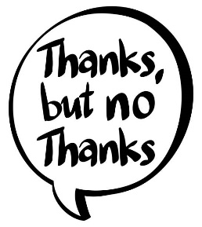

Stamp Your Learning for Peer Pressure Vocabulary
Directions: In your neatest handwriting and in complete sentences, answer the following questions:

- As your teacher begins passing out a quiz, your friend leans forward and whispers in your ear: “I didn’t study! You don’t care if I look at yours, right? If I don’t get at least an 80%, my mom said I’m grounded.”

This is an example of:
- Refusal Skills
- Rejection
- Reasoning
- Self-Awareness

- Go back to the scenario in question 1. If you feared rejection, after your friend’s request, what might you have said?

____________________________________________________________________________________________________________________________________________________________________________________________________________________________________________________________________________________________________________________________________________________________

- Go back to the scenario in question 1. You chose to use a refusal skill by not responding to your friend. What is another refusal skill you could have used?

____________________________________________________________________________________________________________________________________________________________________________________________________________________________________________________________________________________________________________________________________________________________

Stamp Your Learning for Peer Pressure Vocabulary (Continued)
- After ignoring your friend’s request, you notice them lean over to another student and begin whispering. They both quickly glance at you before picking up their pencils. Is this an example of peer pressure? Why or why not?

____________________________________________________________________________________________________________________________________________________________________________________________________________________________________________________________________________________________________________________________________________________________
- Circle all the examples of unspoken pressure below.
- Rolling your eyes at your friend when they say “No, thanks.” to shoplifting.
- Smiling when your friend earns a reward in class.
- Raising your hand each time your teacher asks a question.
- Pointing and laughing at another student who is not close enough to hear you, but can see you.
- Shrugging your shoulders at your friend when they ask if they should do their homework or go to the movies.

- Complete this idea: Someone with a strong sense of self-awareness…

____________________________________________________________________________________________________________________________________________________________________________________________________________________________________________________________________________________________________________________________________________________________

People talking, Shoulder Shrug Emoji Girl Getting Bullied, List icon, Happy and Sad Face, and Thank you Clip by Unknown are licensed by Creative Commons Deed CC0.
peer: someone your age or close to your age

