**Name**: __________________________ **Date: __________________**

**Homeroom**: _____________________

***What are SMART Goals?***

**Directions:** Review the following SMART Goals graphic and answer the questions that follow.

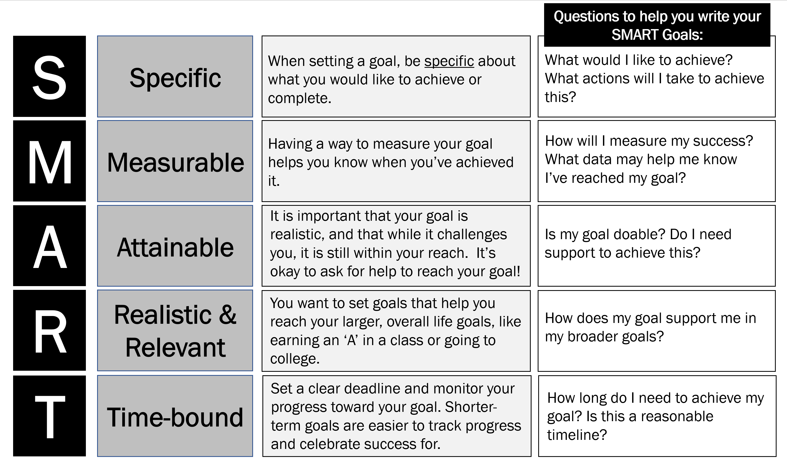

**Stop & Jot:** Which of the parts of writing a SMART goal do you think will be most challenging for you (Specific, Measurable, Attainable, Realistic & Relevant, or Time-bound)?

__________________________________________________________________________________________

Based on your answer above, what questions might you ask yourself in order to write your SMART goal?

______________________________________________________________________________________________________________________________________________________________________________________________________________________________________________________________________________

***What are SMART Goals?* Reflection Questions**

**Directions:** In your neatest handwriting and in complete sentences, answer the following questions:

Below, you’ll see a student named Desiree’s goals for school and for soccer. With some support from her teacher, Desiree rewrote her goals to be SMART. Use the questions below to reflect on how Desiree’s Re-written SMART Goals better set her up for success than her original goals.

**Desiree’s 1st Goal: Her Grade in Science Class**

|  |  |
| --- | --- |
| **Original Goal** | I will improve my grade in science class. |
| **Re-written SMART Goal** | In the next three weeks, I will improve my grade from an 82% to at least a 90% in science by attending tutoring 2 times per week and studying my vocabulary flashcards 15 minutes per day. |

1. Using the SMART goal graphic on pg. 1, how is Desiree’s re-written SMARTgoal more measurable than her original goal?

_____________________________________________________________________________________________________________________________________________________________________________________________________________________________________________________________________

1. How is Desiree’s re-written SMARTgoal more time-bound than her original goal? Why is this important?

_____________________________________________________________________________________________________________________________________________________________________________________________________________________________________________________________________

***What are SMART Goals?* Reflection Questions (Continued)**

**Desiree’s 2nd Goal: Scoring Goals in Soccer**

|  |  |
| --- | --- |
| **Original Goal** | I will get better at soccer. |
| **Re-written *SMART* Goal** | I will improve my ability to score a goal in soccer by practicing my shooting drills (side shooting, one touch shooting, and dribbling) for 30 minutes everyday for the next two weeks. I will know I’ve reached a goal when I am able to score at least two goals in each practice. |

1. Based on the SMART Goal graphic on pg. 1, how is Desiree’s Re-written SMARTGoal more specific than her Original Goal?

_____________________________________________________________________________________________________________________________________________________________________________________________________________________________________________________________________

1. Now that you have seen two examples of Desiree’s goals re-written to be SMART, what do you think the impact of SMART Goals are on being able to reach those goals? Why?

____________________________________________________________________________________________________________________________________________________________________________________________________________________________________________________________________________________________________________________________________________________________

**Stamp Your Learning for *What Are SMART Goals?***

**Directions:** Answer the following prompts and questions in complete sentences.

1. Name and describe one specific goal you have for yourself academically.

____________________________________________________________________________________________________________________________________________________________________________________________________________________________________________________________________________________________________________________________________________________________

1. Name and describe one specific goal you have for yourself behaviorally.

____________________________________________________________________________________________________________________________________________________________________________________________________________________________________________________________________________________________________________________________________________________________

1. What support do you think you need in order to reach the goals you described above? This support could be from friends, teachers, or family.

____________________________________________________________________________________________________________________________________________________________________________________________________________________________________________________________________________________________________________________________________________________________

______________________________________________________________________________________________________________________________________________________________________________