Name: __________________________ Date: __________________
Importance of Positive Emotions
Objective: To examine results from an experiment in positive psychology and identify benefits of
positive emotions.

Evolution and Emotions
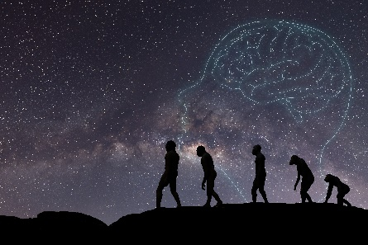
We tend to think about our emotions on a personal level—certain things bring us joy while other things make us upset. However, our emotions have a history that started long before we were born. Evolutionary biologists tell us that emotions have adapted over time based on their ability to ensure the survival of humanity.
Scientists who study emotions have explained that so-called negative emotions, like anger and fear, promoted the survival of our ancestors in life-threatening situations. For instance, if our ancestors feared something, whether a hoard of rampaging beasts or crossing the ocean during a raging storm, they likely avoided it, and were spared from being trampled or lost at sea.
But what about positive emotions? How might being happy help someone to survive? Psychologist Barbara L. Frederickson said in a paper in American Scientist, “positive emotions, on the other hand, aren’t so easily explained [as negative emotions]. From this evolutionary perspective, joy, serenity, and gratitude don’t seem as useful as fear, anger, or disgust. If positive emotions didn’t promote our ancestors’ survival in life-threatening situations, then what good were they? Did they have any adaptive value at all? Perhaps they merely signaled the absence of threats.”
- Consider some positive emotions, like joy, happiness, gratitude, and amusement, and the impact they have on your life. What might some potential benefits of positive emotions be? List a few below:

- What do you think: Might positive emotions impact people's survival—literally save their lives?
______________________________________________________________________________________________________________________________________________________________________________________________________________________________________________________________________________
Importance of Positive Emotions (Continued)
Positive Emotions’ Impact on Stress
Barbara Frederickson wanted to understand whether positive emotions (joy, happiness, contentment) could counteract the harmful impacts of negative emotions (stress, anger, etc.).
Frederickson and some of her psychology students designed an experiment to determine if this is possible. Researchers can measure stress by monitoring a person’s cardiovascular (heart) health—their heart rate and blood pressure—since heart rates and blood pressure increase when a person feels stressed. So, the experiment began by establishing baseline measurements for a group of participants’ cardiovascular health to determine what the participants’ resting measurements were before any kind of emotion was experienced.
Next, the researchers told the group of participants that they had one minute to prepare a speech. They also explained that the speech would be filmed and observed by peers. When they made this announcement, the researchers noted any changes in the participants’ cardiovascular measurements.
- Check-in with your own emotions—how would you feel if you were told to prepare a filmed speech for an audience in less than a minute? What would you expect to happen to your heart rate and blood pressure?
____________________________________________________________________________________________________________________________________________________________________________________
You probably said something like you would feel stressed or anxious. This was the goal of the researchers—to prompt feelings of anxiety in the participants. The researchers needed to produce stress in the participants, in order to increase participants’ heart rates and raise their blood pressures.
Lastly, they randomly assigned each participant to watch a short film that elicited one of four emotions: amusement, contentment, no emotion, or sadness. Researchers told the participants that they didn’t actually have to prepare the speech, showed the participants their respective film, and then measured how long it took for the participants’ cardiovascular measurements to return to baseline (their initial resting measurements). This was to see how quickly participants were able to recover from the initial anxiety.
- Pause: Take a moment to make a prediction. Which group(s) do you think will recover fastest from the initial anxiety? Which do you predict will recover slowest? Briefly explain your thinking.

- Fastest recovery: ________________________________________________________________________

- Slowest recovery: ________________________________________________________________________

- Brief explanation of your predictions: ________________________________________________________
_________________________________________________________________________________________
__________________________________________________________________________________________
Importance of Positive Emotions (Continued)
- The diagram below shows the results of the study. Take a moment to look them over and answer the questions below.
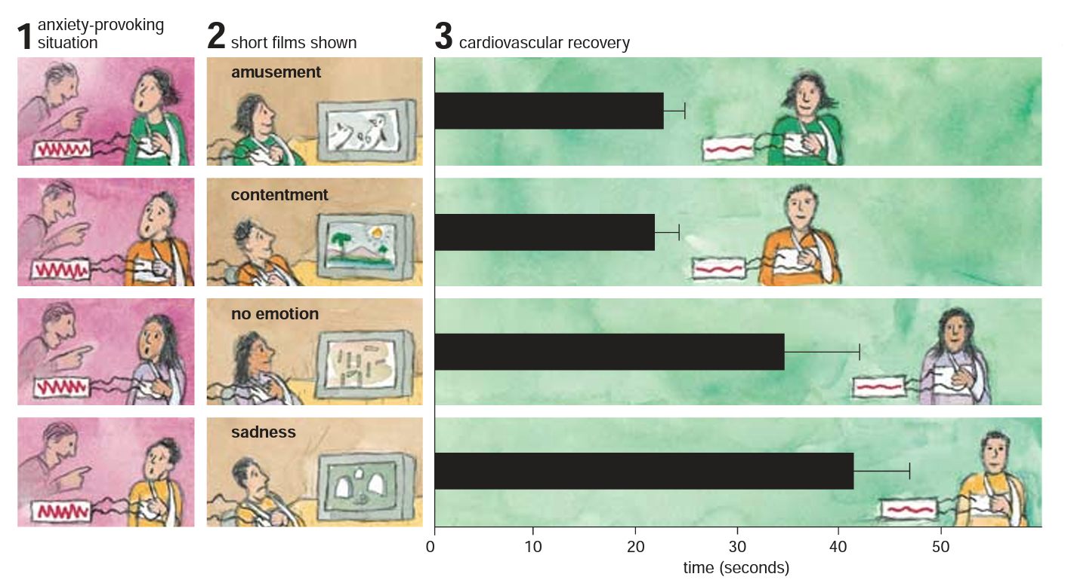
- Which group(s) have the fastest recovery time? Does this align with your predictions? Explain your response.
______________________________________________________________________________________________________________________________________________________________________________________________________________________________________________________________________________
- Which group(s) have the slowest recovery time? Does this support or refute your predictions? Explain your response.
______________________________________________________________________________________________________________________________________________________________________________________________________________________________________________________________________________
- Why might the researchers show a film that elicits "no emotion"? What does the recovery time associated with "no emotion" tell us about the positive or negative emotions?
______________________________________________________________________________________________________________________________________________________________________________________________________________________________________________________________________________
Reflection Questions for The Importance of Positive Emotions
- What do you think the takeaway from this study is? How might you use the results as a lesson for your everyday life?
__________________________________________________________________________________________________________________________________________________________________________________________________________________________________________________________________________________________________________________________________________________________________________________________________________________________________________________________________
Stamp Your Learning for The Importance of Positive Emotions
- Frederickson analyzed the results of her experiment, and captured her takeaway, which she calls “The Undoing Hypothesis.”
The Undoing Hypothesis
Basically, the Undoing Hypothesis says that we might be able to use positive experiences (like watching the video that produces feelings of contentment) to combat the negative physiological experiences from anxiety (increased heart rate, for example). This is important, because the effects of stress and negative emotions, if they are persistent and prolonged, can worsen heart disease and other harmful conditions in the body. Frederickson and her students concluded, “Positive emotions had a clear and consistent effect of undoing the cardiovascular (heart-related) repercussions of negative emotions.”
physiological: relating to the body’s functions
- Was your takeaway in Q6 similar or different from the Undoing Hypothesis?
________________________________________________________________________________________________________________________________________________________________________________________________________________________________________________________________________________________________________________________________________________________________________
- So, how can positive emotions impact/improve people's survival?
________________________________________________________________________________________________________________________________________________________________________________________________________________________________________________________________________________________________________________________________________________________________________

Barbara L. Frederickson, “The Value of Positive Emotions” American Scientist, no. 91 (July-August 2003): 332.
Barbara L. Frederickson, “The Value of Positive Emotions” American Scientist, no. 91 (July-August 2003): 334-335.

