Name: __________________________ Date: __________________
Homeroom: _____________________
Defining Honesty and Integrity
Directions: Read the definitions of these key terms and answer the questions that follow.
Honesty
Honesty means to tell the truth about a given situation. When you’re honest, you’re sincere and accurate in describing exactly what happened and how you felt about something. Being honest means saying what we know and believe, even when doing so might lead to negative consequences. When we are honest, we show others that we are mature and can take responsibility for our actions, which is a sign of being a young adult.

Integrity
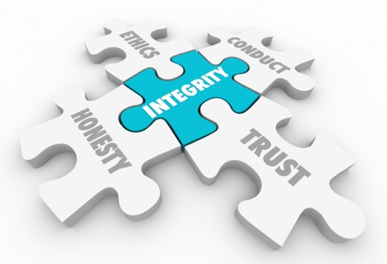 | Integrity is the quality of being honest and fair. If we show honesty in different situations, we will develop integrity, or a reputation of being trustworthy and reliable. When we show integrity to others, they come to know they can rely on us and believe what we have to say. In the long run, being known as having integrity is more valuable than whatever benefits you might gain from being dishonest in a given situation.

Defining Honesty and Integrity (Continued)
Directions: Review the definitions above and answer the questions below. Be sure to include the bolded word in your response.
Application of Terms
- Describe a time when you chose to be honest, even if it meant you would face negative consequences. How did you feel after?

__________________________________________________________________________________________________________________________________________________________________________
_____________________________________________________________________________________
- Describe someone in your life who you believe models integrity. Explain why.
_____________________________________________________________________________________
_____________________________________________________________________________________
_____________________________________________________________________________________
- Can you be honest in a given situation, but still lack integrity? Explain.

_______________________________________________________________________________________________________________________________________________________________________________________________________________________________________________________________
- You just won a lifetime achievement award, and your best friend is asked to say a few words about you. How would you rather be described: as honest, or as having integrity? Why?

__________________________________________________________________________________________________________________________________________________________________________
_____________________________________________________________________________________

Stamp Your Learning for Defining Honesty and Integrity
Directions: Answer the following questions in complete sentences.
- Describe a recent situation where you showed integrity. Explain why you decided to do that.

________________________________________________________________________________________________________________________________________________________________________________________________________________________________________________________________________________________________________________________________________________
- In one artful sentence, explain how showing integrity can affect a person’s trustworthiness.
____________________________________________________________________________________________________________________________________________________________________________________________________________________________________________________________

- Describe two ways you can show more integrity in your everyday life. Be specific.
________________________________________________________________________________________________________________________________________________________________________________________________________________________________________________________________________________________________________________________________________________

