Name: __________________________ Date: __________________
Homeroom: _____________________
Achieving, Despite Setbacks
Directions: Read the following article and answer the questions that follow. As you read:
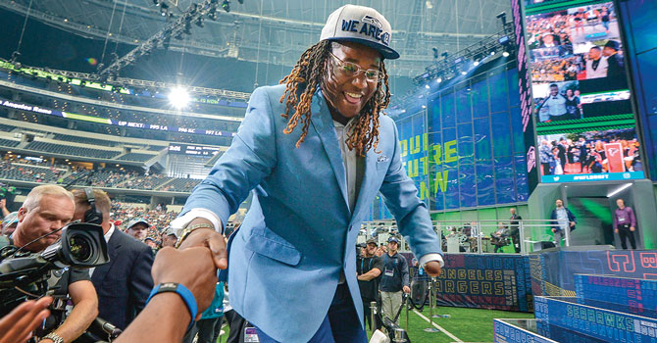
- Underline information that relates to self-belief.
MAX FAULKNER/FORT WORTH STAR-TELEGRAM/TNS
VIA GETTY IMAGES
- Star (*) anything you find interesting or surprising.
- Jot down any questions you would ask Shaquem.
Linebacker with No Limits
Shaquem Griffin is at the top of his game. [In 2017], this 23-year-old linebacker led his college football team to an undefeated season. He then went on to stun observers with his strength, speed, and charisma at a National Football League (NFL) recruiting event. Griffin’s skill on the field isn’t the only thing that makes him a standout athlete. He also recently became the first one-handed player ever drafted by an NFL team. Griffin was born with a left hand that hadn’t fully developed. The condition was extremely painful, and his parents decided to have doctors amputate, or remove, his hand when he was just 4 years old. Afterward, Griffin and his family decided they’d never let his physical difference hold him back. When he fell in love with football as a child, some people didn’t think he should play the sport. But that wouldn’t stop Griffin. “Nobody was ever going to tell me that I didn’t belong on a football field,” he wrote in a recently published essay in The Players’ Tribune.
Today, Griffin is gearing up to start his first season with the Seattle Seahawks. With his professional career about to begin, Science World takes a look at how he got to where he is today.
ROUGH START
Griffin’s medical condition began prenatally, or before birth. During his mother’s pregnancy, doctors took a routine ultrasound. The procedure, which uses high-frequency sound waves to create an image, revealed an unusual problem: a strand of fibrous tissue inside the womb had wrapped around Griffin’s left hand. This condition is called amniotic band syndrome, or ABS. “We still don’t know exactly why it happens,” says Dr. Hanmin Lee, who studies ABS and other prenatal conditions at the University of California, San
Achieving, Despite Setbacks (Continued)
Francisco. “But when it does, it basically strangulates parts of the body—most commonly, the hands, arms, or legs.”
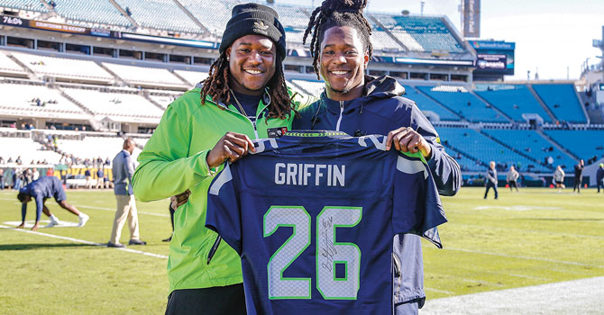
DON JUAN MOORE/GETTY IMAGES
TWIN TIME: Shaquem (left) and his twin brother, Shaquill, are reunited on the Seattle Seahawks.
[…] It’s possible to treat amniotic band syndrome while a baby is still in the womb. Physicians like Lee can perform an operation to remove the band before it causes too much damage. In Griffin’s case, though, there was a complicating factor: Griffin shared the womb with his twin brother, Shaquill. A surgery would have risked injuring him. The Griffins and their doctors decided to let the condition take its course.
“Shaquem’s story is inspiring,” says Lee, who has followed the football player’s career. “I hope other kids…can read about his success and know that it’s okay to be different—it’s about becoming the best version of yourself that you can be.”
Stop and Jot: In one sentence, how would you describe Shaquem Griffin?
________________________________________________________________________________________________________________________________________________________________________________________________________________________________________________________________________
RAISING TWO CHAMPS
From the moment Griffin was born, his parents decided to raise him no differently than his twin brother. As the two boys grew up, they became inseparable at home, at school, and on the football field. Griffin and his twin brother both trained to be football players from a young age, and Griffin refused to let his missing hand prevent him from tackling opponents or throwing and catching the ball. He wanted to play just as hard as anyone.
When he was in high school, Griffin’s parents built him special devices—like a cloth-covered piece of wood that made it easier to do bench presses and straps that helped him do bicep curls—to help him work out
Achieving, Despite Setbacks (Continued)
despite his missing hand. The training worked: By the time he was a high school senior, Griffin could bench-press 118 kilograms (260 pounds).
When it came time to graduate high school in 2013, the boys fulfilled a lifelong promise to always stick together, and both headed to the University of Central Florida (UCF) in Orlando. There, they joined the school’s football team. Although Shaquill was given a starting position, Shaquem wasn’t. But after three seasons, his speed and strength couldn’t be overlooked. In 2016, he was picked to play in the team’s starting lineup, and scouts for the NFL began to notice.
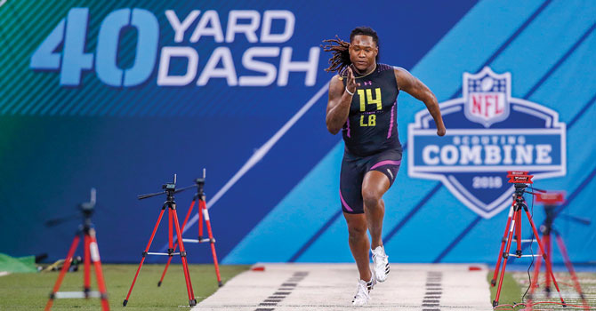
MAKING THE TEAM
BRIAN SPURLOCK/USA TODAY SPORTS/SIPA USA
LIKE LIGHTNING: Griffin ran the fastest-ever 40-yard dash for a linebacker.
In 2018, Griffin was invited to attend the scouting combine, a special weeklong event hosted by the NFL, in which hopeful players endure physical tests in front of scouts, coaches, and team managers. An athlete’s performance at the combine influences whether or not he might be drafted into one of the league’s 32 teams.
Going into the combine, Griffin was still far from a household name. He had won many accolades for his final two seasons at UCF, but his brother, Shaquill, was the better-known player. That didn’t last long. At the combine, Griffin ran the fastest-ever 40-yard dash—one of the main events—by a
linebacker. His time of 4.38 seconds tied his brother, who weighs less and plays a speedier cornerback position. Next, Griffin bench-pressed 102 kg (225 lbs)—20 times—using a prosthetic hand. And just as important as his physical feats, Griffin’s attitude and spirit made it clear that he had what it takes to help teams win championships.
It wasn’t long after the combine that Griffin learned he’d been picked to play with the Seattle Seahawks. His brother had joined the team one year earlier. So, starting this fall, they’ll be playing football together once again. Win or lose, Griffin knows that he’s made it. “I don’t define myself by my successes,” Griffin says. “I define myself by adversity, and how I’ve persevered.”
Achieving, Despite Setbacks Reflection Questions
Directions: Now that you have read the article and learned more about Shaquem’s story, complete the sentences below to describe how he was able to achieve his goals, despite setbacks.

- No one believed Shaquem Griffin would become an NFL player, but…
_____________________________________________________________________________________________________________________________________________________________________________________________________________________________________________________________________
No one believed Shaquem Griffin would become an NFL player, because…
_____________________________________________________________________________________________________________________________________________________________________________________________________________________________________________________________________

No one believed Shaquem Griffin would become an NFL player, so…
_____________________________________________________________________________________________________________________________________________________________________________________________________________________________________________________________________

Achieving, Despite Setbacks Reflection Questions (Continued)
- Re-read the following section of the article and answer the questions that follow.
“Shaquem’s story is inspiring,” says Lee, who has followed the football player’s career. “I hope other kids…can read about his success and know that it’s okay to be different—it’s about becoming the best version of yourself that you can be.”
- What does it mean to become “the best version of yourself that you can be”?
____________________________________________________________________________________________________________________________________________________________________________________________________________________________________________________________________________________________________________________________________________________________________________________________________________________________________
- What would it look like for you to be “your best version of yourself that you can be”?
____________________________________________________________________________________________________________________________________________________________________________________________________________________________________________________________________________________________________________________________________________________________________________________________________________________________________
- What specific steps do you need to take to become the “best version of yourself that you can be”?
____________________________________________________________________________________________________________________________________________________________________________________________________________________________________________________________________________________________________________________________________________________________________________________________________________________________________
Stamp Your Learning for Achieving, Despite Setbacks
Directions: Answer the following questions in complete sentences.
- What is one lesson you’ve learned from Shaquem’s experience?
___________________________________________________________________________________________________________________________________________________________________________________________________________________________________________________________________________________________________________________________________________________________________________________________________________________________________________________

- How can you transfer this lesson to your own goals?
___________________________________________________________________________________________________________________________________________________________________________________________________________________________________________________________________________________________________________________________________________________________________________________________________________________________________________________

- How will overcoming setbacks to achieve your goals help you in the future?
___________________________________________________________________________________________________________________________________________________________________________________________________________________________________________________________________________________________________________________________________________________________________________________________________________________________________________________

Scholastic Science World: Linebacker Without Limits by J. Batchelor https://scienceworld.scholastic.com/issues/2018-19/091718/linebacker-with-no-limits.html?promo_code=8655&magazineName=sw&eml=CM/smd/20190422//txtl/marketingblog/edsw#1050L. Accessed on 11/8/19.
stun: surprise very much
strangulates: stops from growing
accolades: awards

