Name: __________________________ Date: ________________________
Homeroom: _____________________ Class: ________________________
brown girl dreaming (1-2) “february 12, 1963”
Lesson Objective: Describe how Woodson connects herself to her family’s history.

Do Now
Directions: Review the map and the brief article below, then answer the questions that follow.
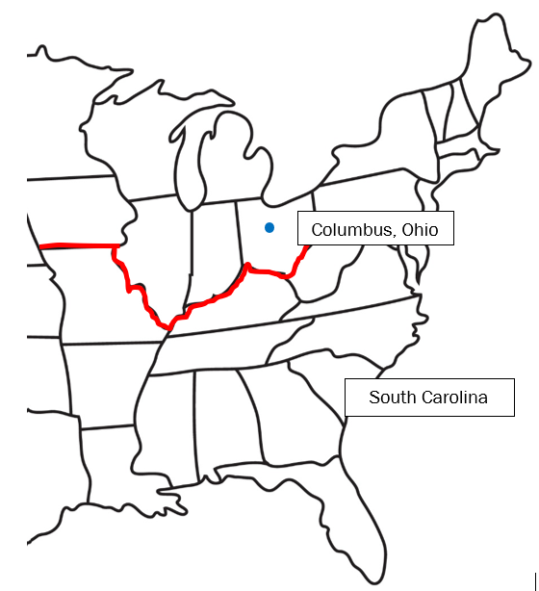
The map to the left shows the location of two important places in Jacqueline Woodson’s life: Columbus, a city in Ohio, and the state of South Carolina. The red line stretching across the middle of the United States represents the Mason-Dixon line, which dates back to the 1700-1800s when slavery was still legal in much of the country. The Northern states above the line were “free” states, where slavery was outlawed, and the Southern states below the line were slaveholding states. Even though slavery has been illegal in every state since 1865, people still refer to the Mason-Dixon line as an imaginary divider between the region of the U.S. known as the North and the region known as the South.

- What did the Mason-Dixon line divide in the 1800s?
____________________________________________________________________________________________________________________________________________________________________________________
- The Mason-Dixon line is still frequently referred to today and holds significance as an “imaginary divider.” Why might it still have a lasting impact on the way people perceive different regions of the U.S.?
______________________________________________________________________________________________________________________________________________________________________________________________________________________________________________________________________________

Vocabulary: Emancipate, Evocative

Word | Definition | Related  Parts of Speech | Situations | Image
emancipate  verb | to set free, especially from a figure of authority | emancipation  noun  emancipated  adjective | - The factory workers decided to emancipate themselves from the unfair restrictions of their bosses.  - _________________________________  _________________________________  _________________________________ | 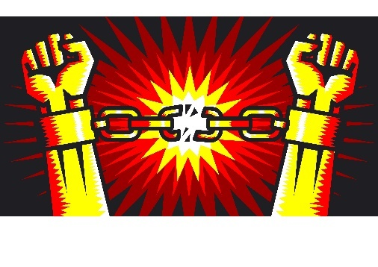
evocative  adjective | bringing to mind strong images, memories, or feelings | evoke  verb | - The flower’s evocative smell made her think of her first family vacation.  - _________________________________  _________________________________  _________________________________

Vocabulary Active Practice

As we apply our new word knowledge, be sure to use the vocabulary word in your answer!
- What images or feelings does this picture evoke for you?

- Consider the information you learned from the map in the Do Now. In the early 1800s, do you think you would be more likely to find a supporter of emancipation in the North or the South? Why?

- When in a movie might a director include a particularly evocative song? Why?

- The musician Bob Marley has a song that includes the famous lyric, “Emancipate yourselves from mental slavery.” What do you think this means?

________________________________________________________________________________________________________________________________________________________________________________________________________________________________________________________________________________________________________________________________________________

- Why might poetry be a particularly evocative form of writing?

________________________________________________________________________________________________________________________________________________________________________________________________________________________________________________________________________________________________________________________________________________

Pages 1-2

- What happened on February 12, 1963?
__________________________________________________________________________________________
More on Memoir
The word memoir comes from the French word for “memory.” This is a helpful way of understanding what a memoir is: an author’s telling of their own life, the way they remember it. Even though memoirs are nonfiction—the author tells the true story of their real life—memoirs are uniquely subjective because they are told from just one person’s experience and perspective. A memoir can be honest, but still not perfectly accurate; in fact, most of them are probably not.
Memoirs are extremely popular, often topping best-seller lists. Reading memoir gives us a peek into the lives of others and helps us understand what life was like in a particular place during a particular time. Authors of memoir often weave personal stories with broader historical and social context so that they can more vividly evoke the time and place of their experiences.
- Consider this line from the article above:
Reading memoir gives us a peek into the lives of others, and also helps us understand what life was like in a particular place during a particular time.
Why might Woodson have called this first poem “february 12, 1963” instead of “my birthday”? What might this suggest about her purpose in writing this memoir?
__________________________________________________________________________________________________________________________________________________________________________________________________________________________________________________________________________________________________________________________________________________________________________________________________________________________________________________________________
Notes

Reread Part 1
- Reread this stanza from p. 1:
I am born not long from the time
or far from the place
where
my great-great-grandparents
worked the deep rich land
unfree
dawn till dusk
unpaid
drank cool water from scooped-out gourds
looked up and followed
the sky’s mirrored constellation
to freedom.
- What is Woodson letting us know about her great-great-grandparents in this stanza? How do you know? Challenge: How might the rhythm of the poem emphasize this idea?
__________________________________________________________________________________________________________________________________________________________________________________
- Turn and Talk: Slavery was declared illegal in the United States in 1865, almost 100 years before Woodson was born. What might Woodson be suggesting when she says she was born “not long from the time” of her great-great-grandparents enslavement?
Notes

“Follow the Drinking Gourd”
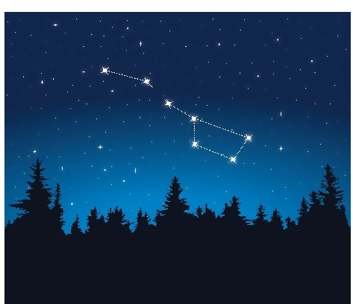
A drinking gourd is a spoon- or cup-like container that can be used to scoop and serve water. In slaveholding states in the American south, the term “drinking gourd” is thought to have been used as a code to refer to the Big Dipper constellation, a formation of stars that looks like a water dipper. This constellation points to the North Star, so it can be used as a navigation tool to help travelers—or escaping slaves—find their way north. The American folk song “Follow the Drinking Gourd,” popular during the Civil Rights movement of the 1950s and 1960s, describes enslaved people using the “drinking gourd” of the Big Dipper as a guide to help them flee north to freedom.
An illustration of the Big Dipper constellation, which points north and looks like a drinking gourd.
Jot: What is Woodson referring to when she describes the “sky’s mirrored constellation”?

- Turn and Task: In the stanza on p. 5, circle the words, phrases, or lines that you find most evocative. You might consider Woodson’s word choice as well as the rhythm and cadence. Share your annotations with a partner. Why did you choose these moments? What images or feelings did they evoke for you?
Notes

Reread Part 2
- Reread these lines from pp. 1-2:
I am born as the South explodes,
too many people too many years
enslaved, then emancipated
but not free
- A paradox is a statement that can be true even though it seems to contradict itself. What makes the phrase “emancipated but not free” a paradox? How could a person be “emancipated but not free”?
______________________________________________________________________________________________________________________________________________________________________________________________________________________________________________________________________________
- What is Woodson suggesting about circumstances in the South in 1963?
______________________________________________________________________________________________________________________________________________________________________________________________________________________________________________________________________________
- Consider these lines from p. 2:
so that today—
February 12, 1963
and every day from this moment on,
brown children like me can grow up
free. Can grow up
learning and voting and walking and riding
wherever we want.
- Look at the circled punctuation mark above, then review the list of poetic terms on your Knowledge Organizer. What is this technique called? ____________________________
- Turn and Talk: What words or ideas are emphasized or separated here? Why?
Notes

- Reread the final stanza:
I am born in Ohio but
the stories of South Carolina already run
like rivers
through my veins.
Why does Woodson have “the stories of South Carolina” in her veins, even though she was born in Ohio? Challenge: What might this suggest about the stories to come in Woodson’s memoir?
__________________________________________________________________________________________________________________________________________________________________________________________________________________________________________________________________________________________________________________________________________________________________________________________________________________________________________________________________
On Your Own: Reread Part 3
“I Was Born”: American Slave Narratives
An important genre of American literature is the slave narrative. Slave narratives are autobiographical accounts written or dictated by formerly enslaved people who shared their stories and experiences of their enslavement and escape. Slave narratives attempted to communicate to a mostly white audience how horrible slavery was in order to persuade readers during the 1800s that the system should be abolished¹.
As slave narrative scholar James Olney notes, almost all slave narratives started with “a first sentence beginning, “I was born…,” then specifying a place but not a date of birth.” This reflected the fact that most enslaved people did not know their exact birth dates. Since enslaved people were considered property, slaveholders did not usually keep accurate written accounts of when the people they owned were born. The phrase, “I was born…” was also intended to reinforce the truthfulness, humanity, and directness of the author and their story.
¹abolished: made illegal
- Review the definition of anaphora on your Knowledge Organizer, then skim the poem again. What anaphora do you notice?
______________________________________________________________________________________________________________________________________________________________________________________________________________________________________________________________________________
- Why might Woodson have borrowed this phrase in her poem?
________________________________________________________________________________________________________________________________________________________________________________________________________________________________________________________________________________________________________________________________________________________________________
- How does the article above add to your understanding of the significance of the title of this poem?
________________________________________________________________________________________________________________________________________________________________________________________________________________________________________________________________________________________________________________________________________________________________________

Name: __________________________ Date: ______________________
Homeroom: _____________________ Class: _____________________
Exit Ticket

- Complete the following sentences:
- Woodson is connected to South Carolina because ________________________________________
________________________________________________________________________________________________________________________________________________________________________
- Woodson is connected to South Carolina, but ____________________________________________
________________________________________________________________________________________________________________________________________________________________________
Challenge:
- Woodson is connected to South Carolina, so ____________________________________________
________________________________________________________________________________________________________________________________________________________________________

Name: __________________________ Date: ______________________
Homeroom: _____________________ Class: _____________________
Homework
Directions: Write a stanza of your own “birthday poem” using “february 12, 1963” as inspiration. Your stanza should begin with “I am born…” and feature at least one of each of the following:
- an enjambment
- a caesura
- an end-stopped line
If you need to, you can reference your Knowledge Organizer for the definitions to these terms. You can also ask a family member or conduct your own research to help you get more information about your personal history as well as the historical context of your birthday.

______________________________________________________________________________________________________________________________________________________________________________________________________________________________________________________________________________________________________________________________________________________________________________________________________________________________________________________________________________________________________________________________________________________________________________________________________________________________________________________________________________________________________________________________________________________________________________________________________________________________________________________________________________________________________________________________________________________________________________________________________________________________________________________________________________________________________________________________________________________________________________________________________________________________________________________________________________________________________________________________________________________________________________________________________

